30 Day Servo Project Build - HMI (here)

The below screens are being created with FactoryTalk View Site Edition Network Distributed.

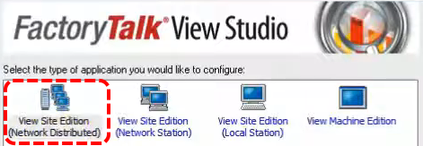

We will not be using Primary/Secondary, this will be just a Primary Solution.

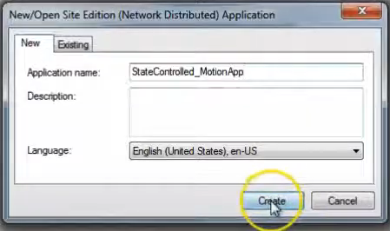

Now we want to setup data server, RS-Lynx, alarming, shortcuts, users, and security.

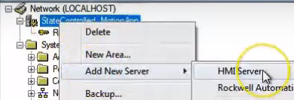

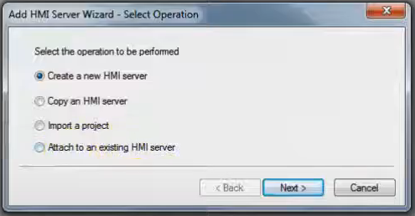

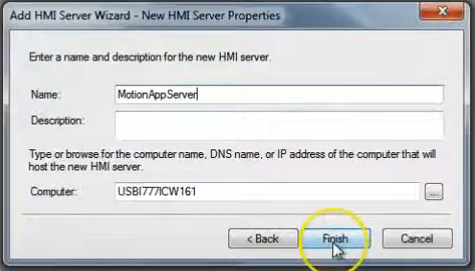

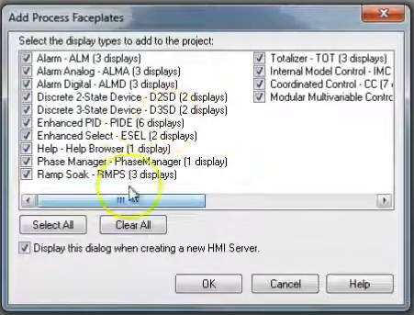

Add all. Then add a new area.

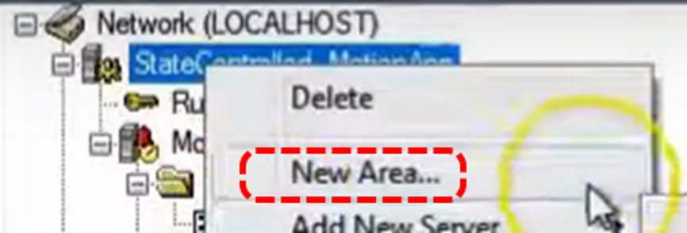

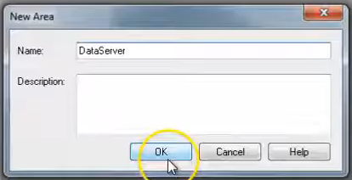

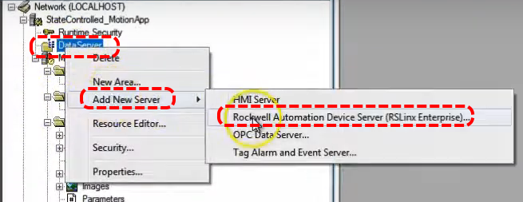

Under Data Server add RS Lynx Enterprise.

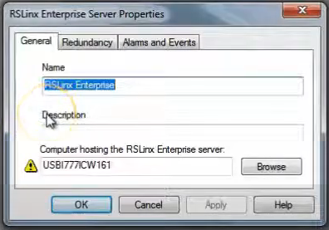

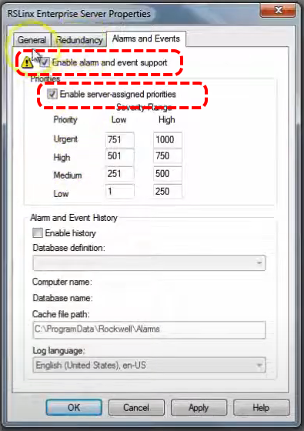

We will not be using Redundancy but will be using Alarms but we will not enable history because we do not have a database.

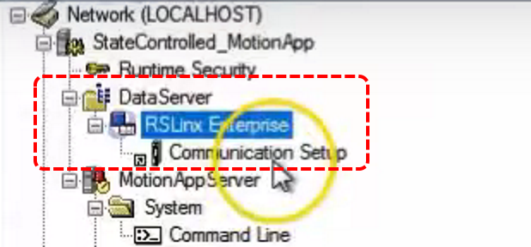

Open the Communications Setup branch. Click Add, give it a name, in this case YouTube. Select the chassis you are using. With the two selected click Apply, dialog appears to create the shortcut.

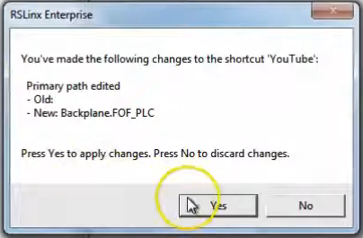

Our application is using Alarms and Events so we must enable it in the Communications screen.

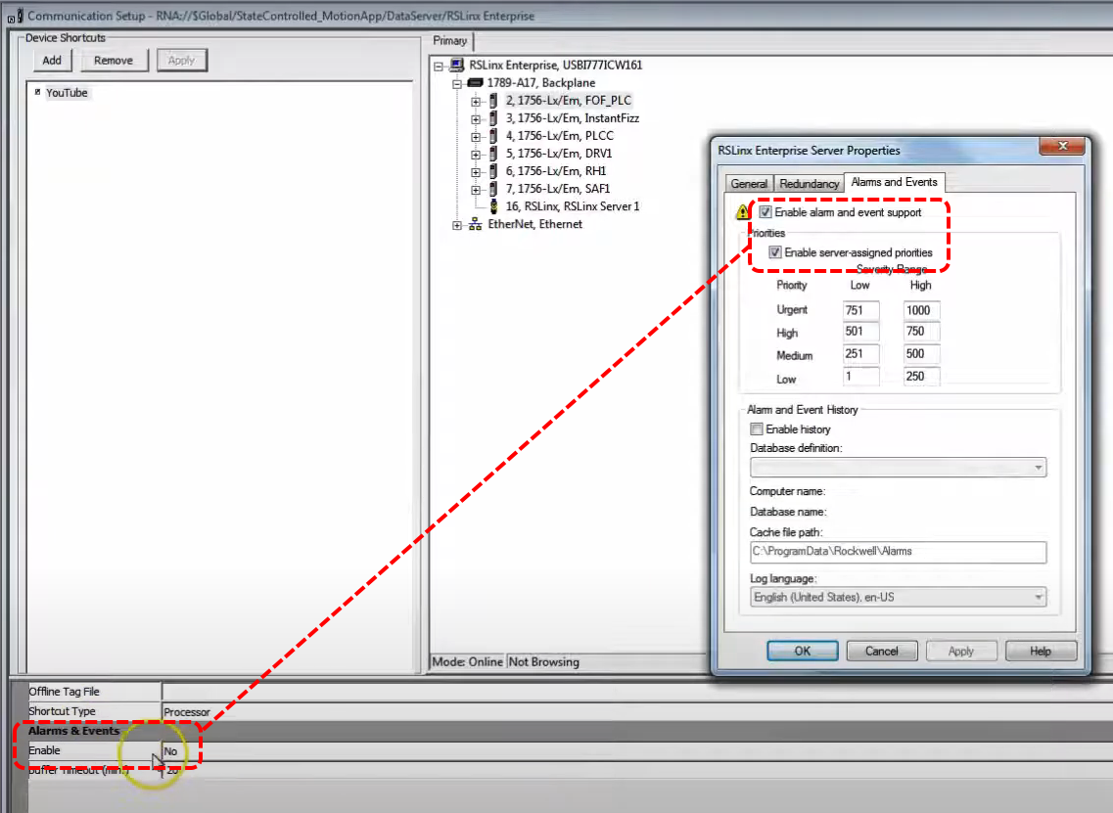

Once you enable Alarms & Events you have to click Apply again, make sure shortcut name and chassis are still selected.

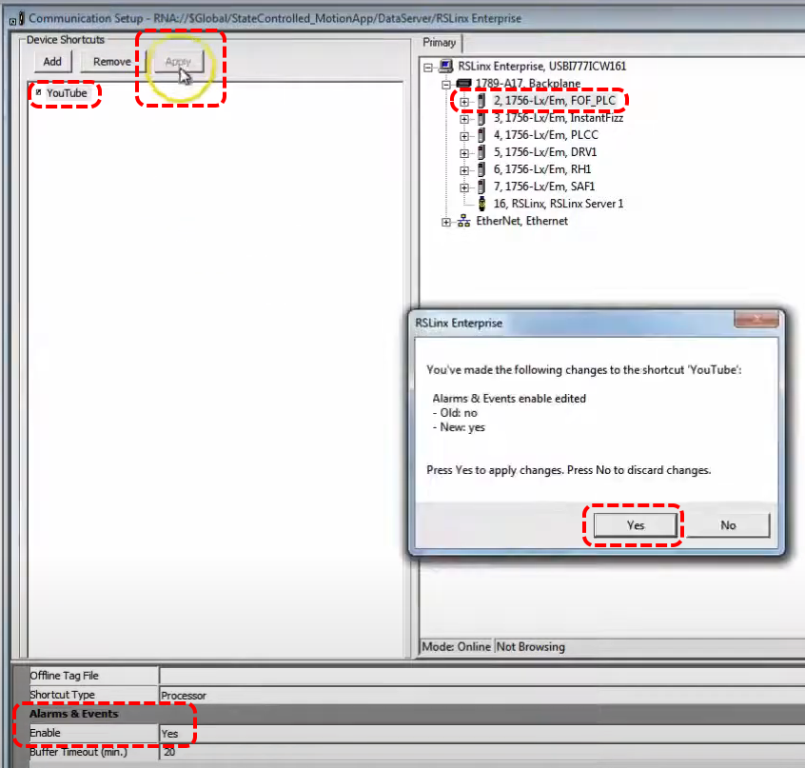

Once that is done you must go to the bottom right corner and click Verify. Then click OK to close.

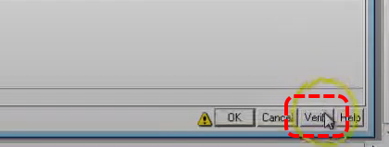
Now open the Runtime Security tab. We will configure an Operator and an Administrator.

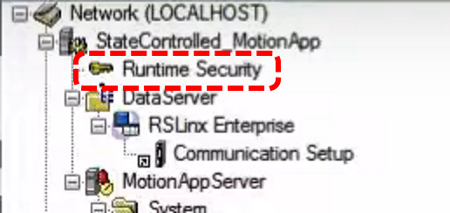

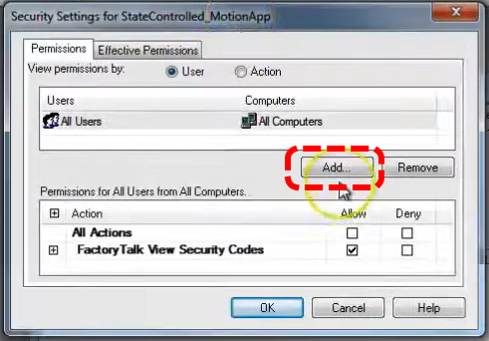

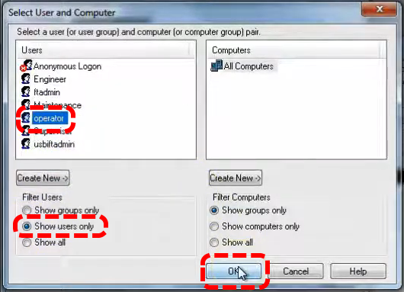
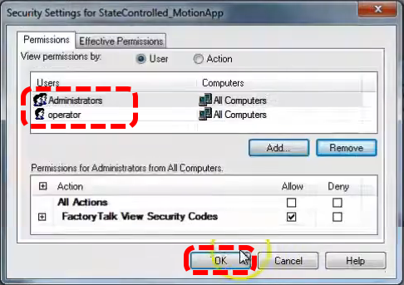

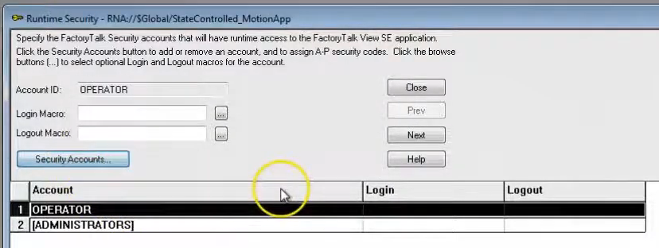

Add and adjust users is pretty much the same as ME version.

Back to HMI. Client Keys are a way to map a key combination which will shut down a screen of system (?). Name our client keys “cliKeys”.
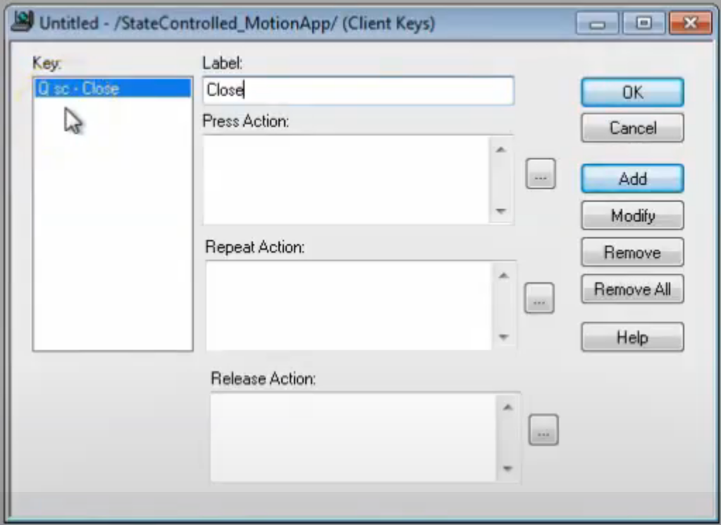
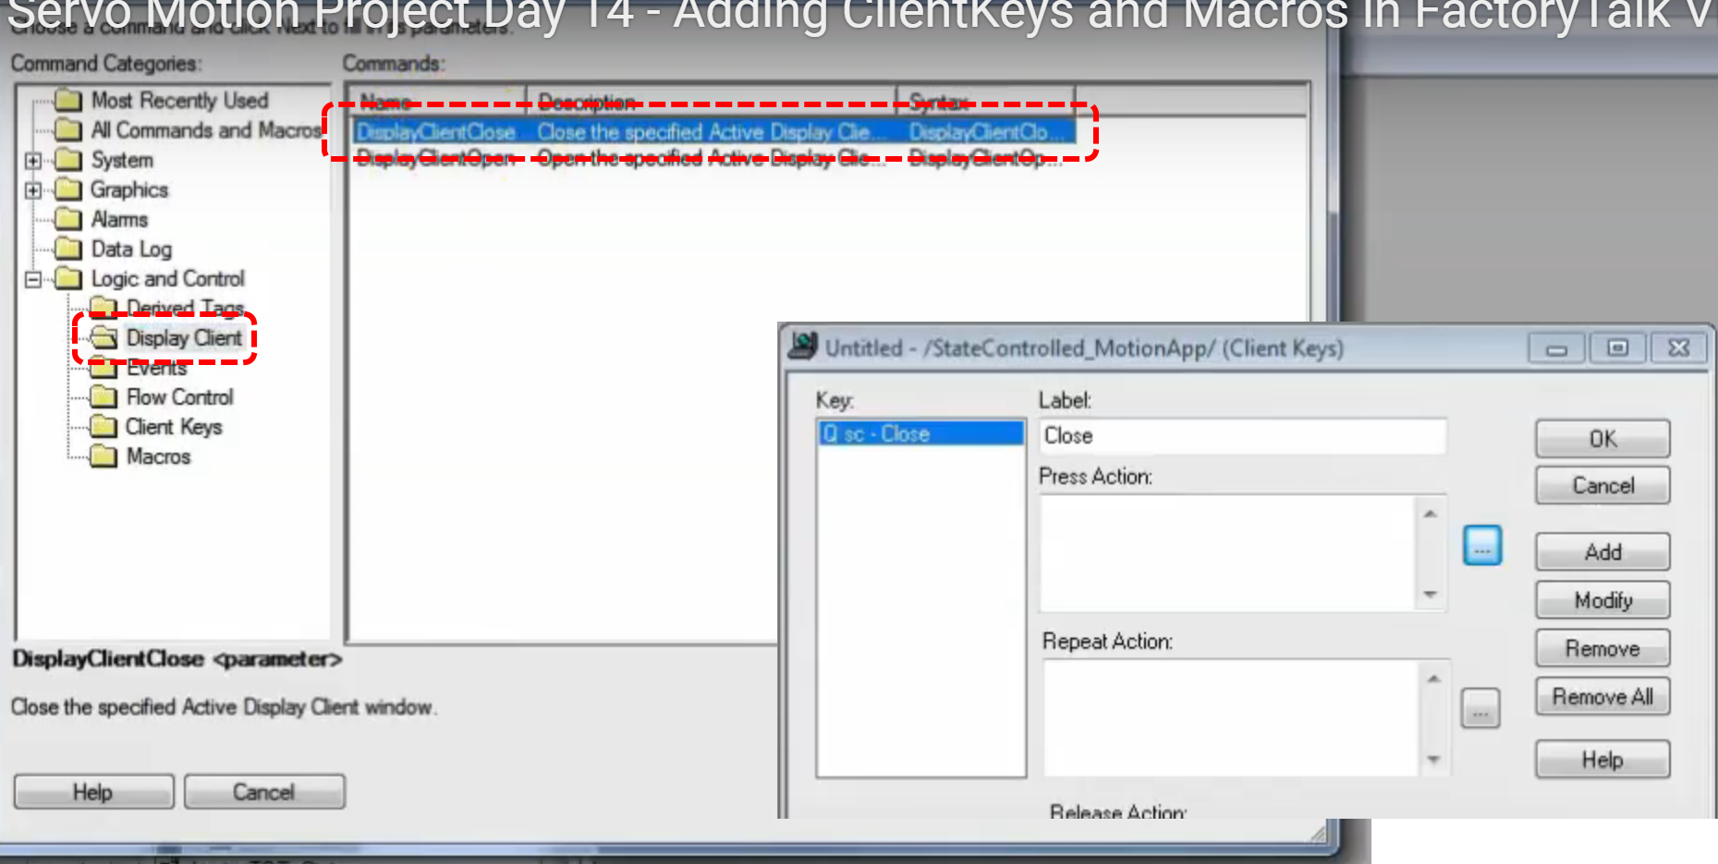

Now we have our client keys, next we set up our macro.

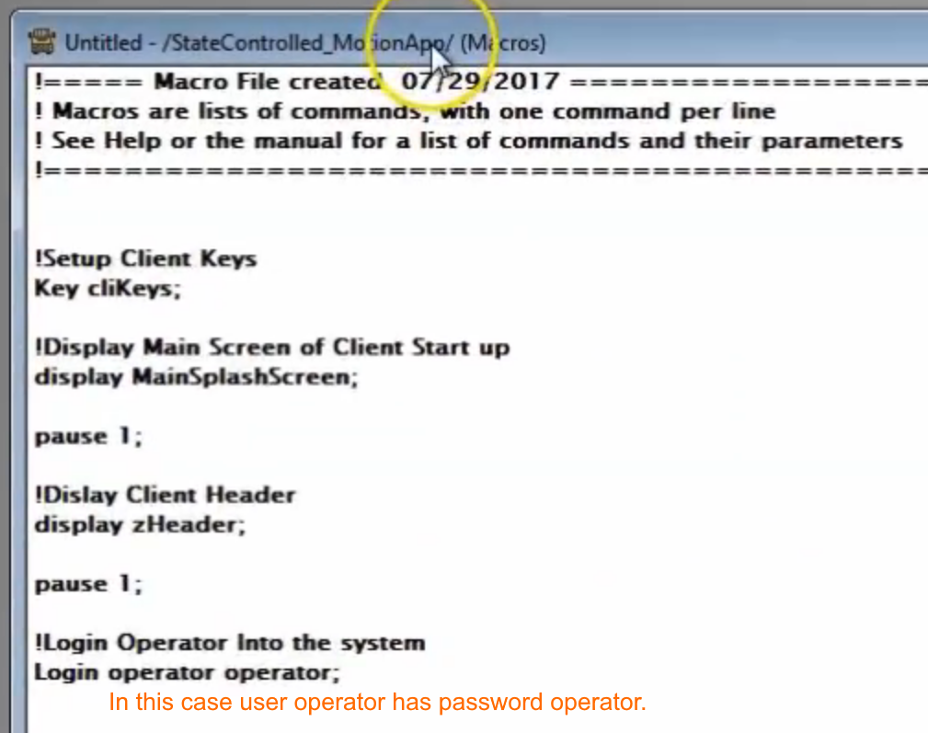

Our Header Screen
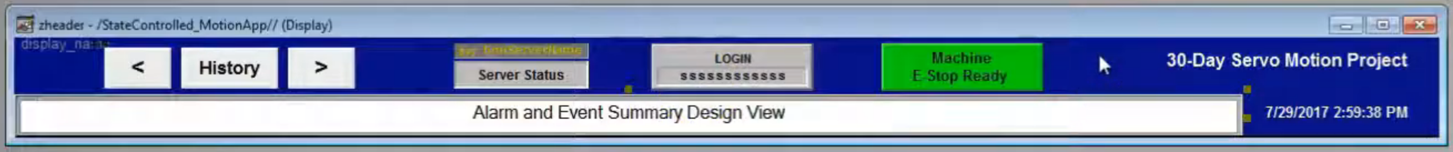
We also added some Alarm & Events items.

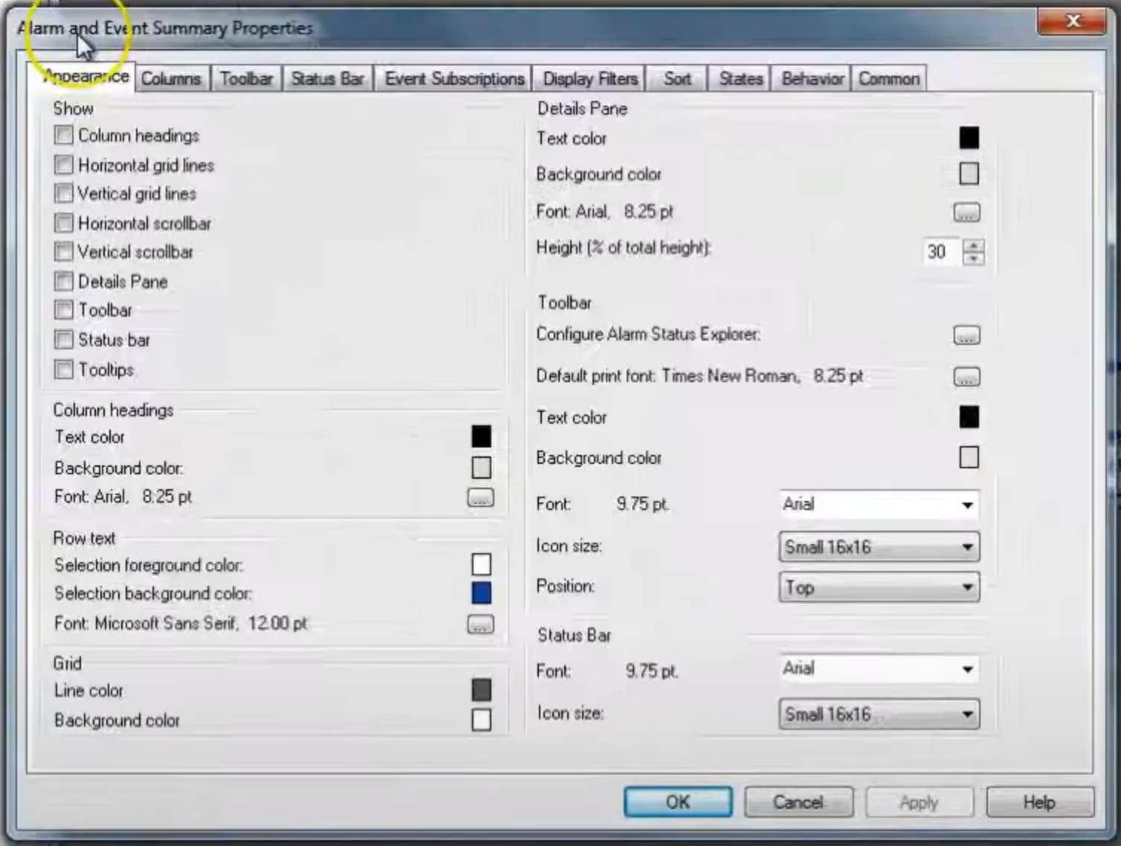

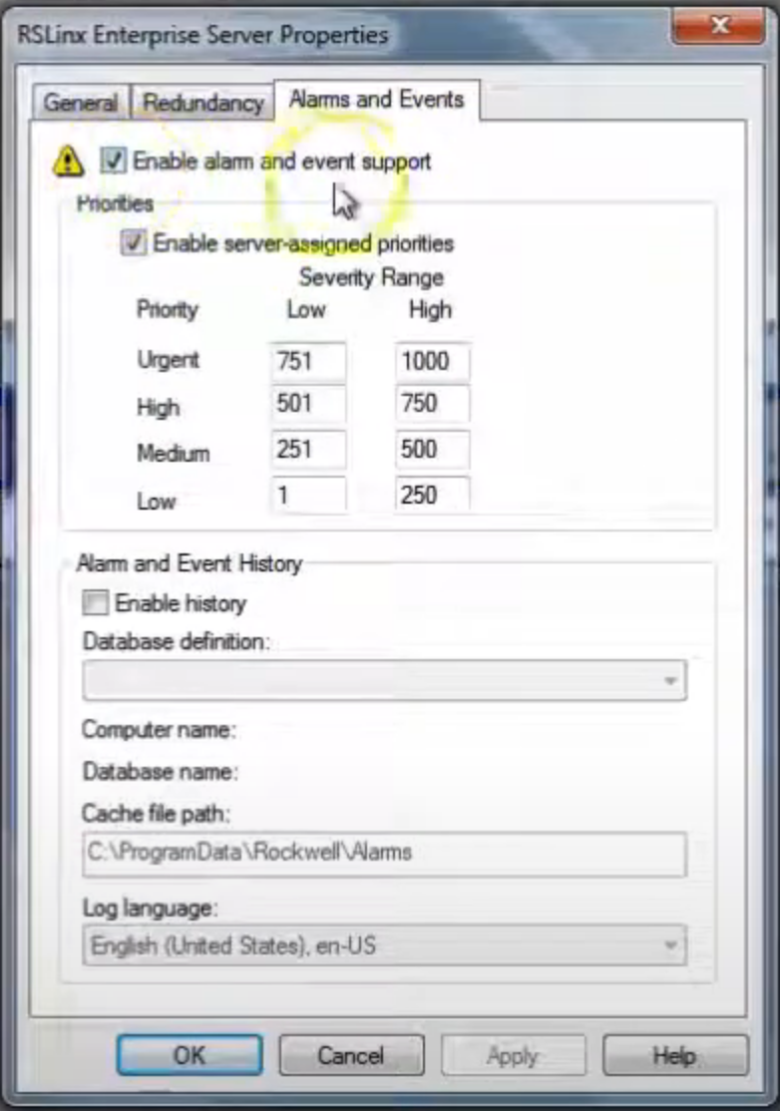

Enabling server side priorities and other RSLynx based alarm & events.

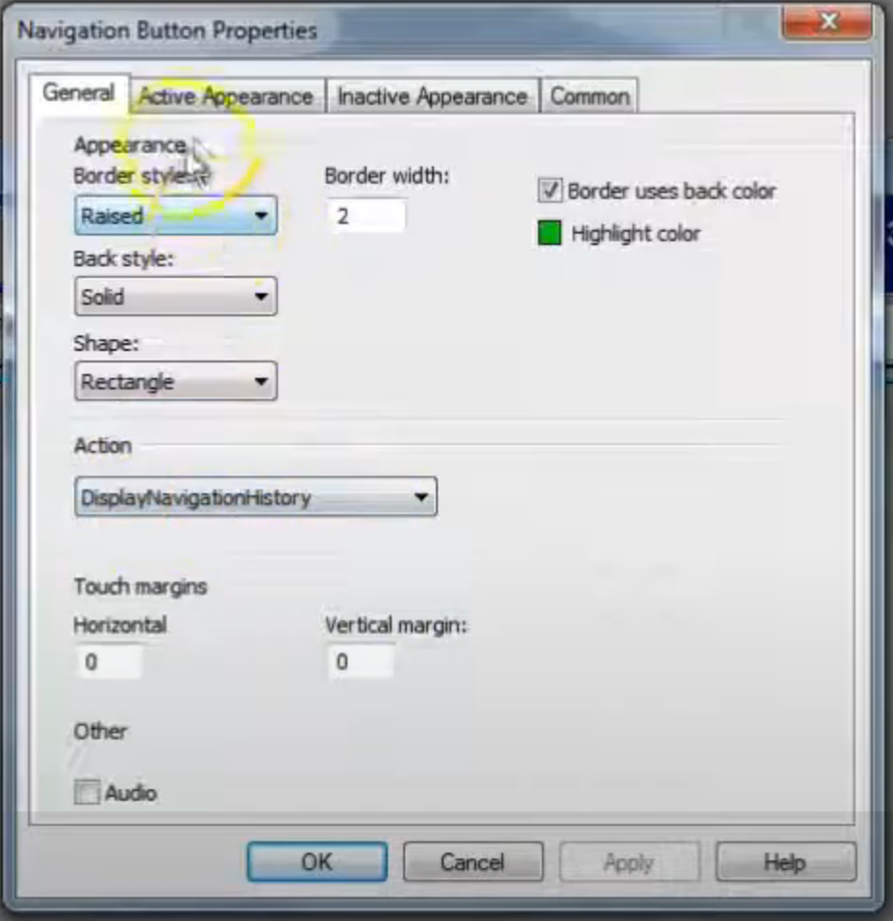

Set up navigation screen items.

Using next screen / prior screen.

Now we are incorporating the below screen. It came from RW knowledgebase and has VBA code behind it. We will examine the code.

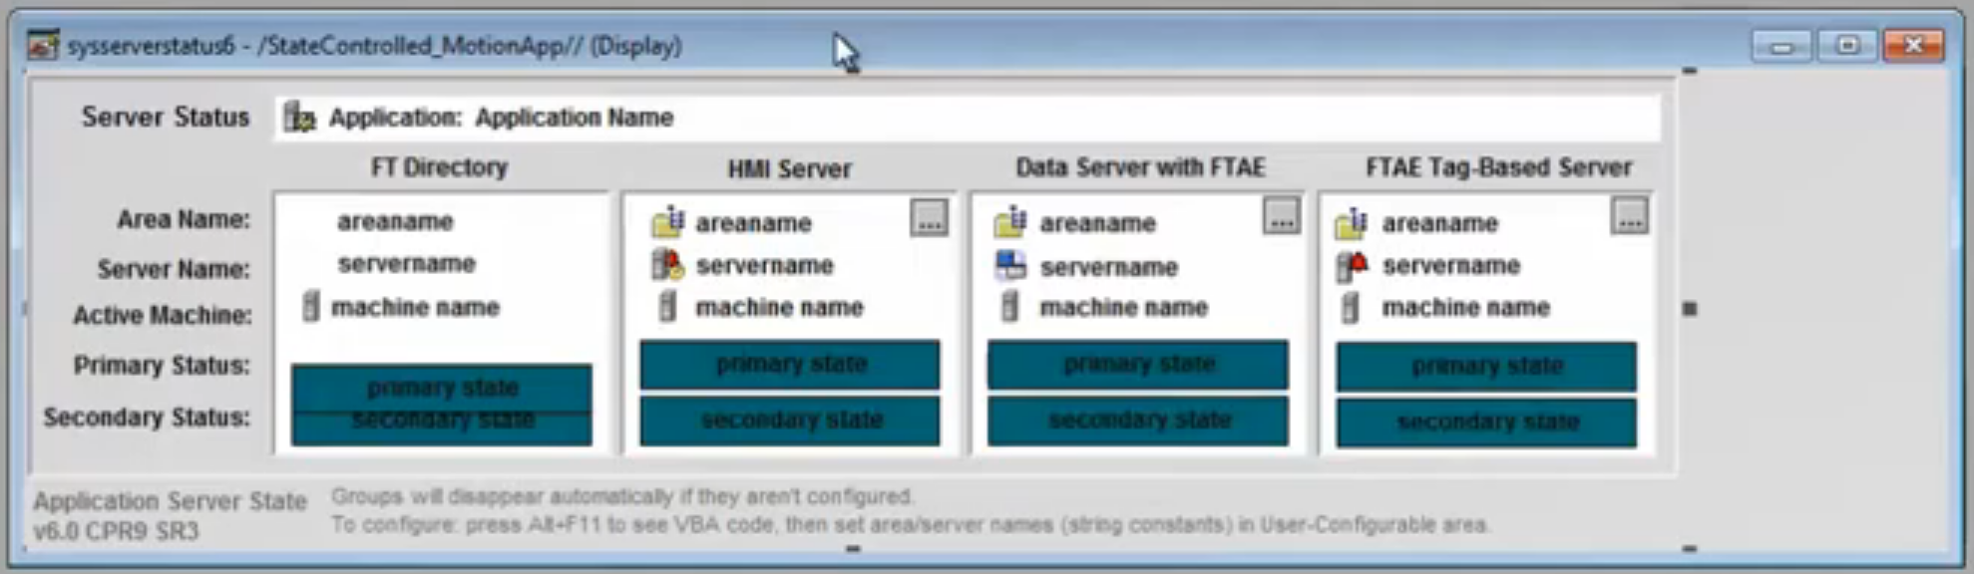

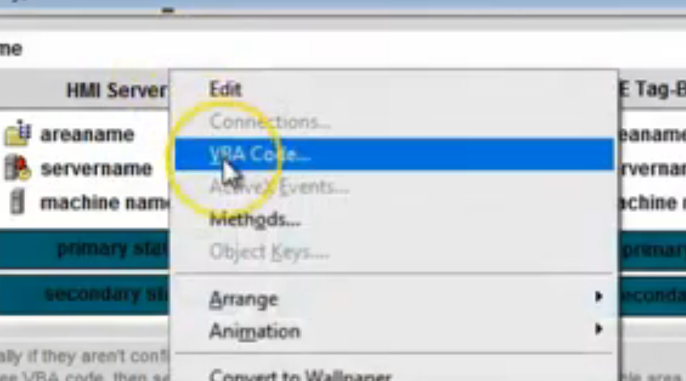

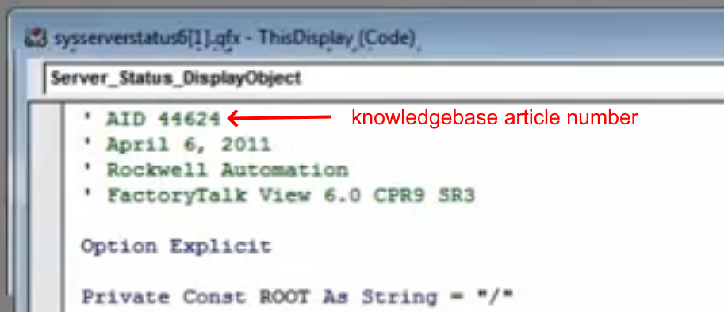

This is kind of an application template.
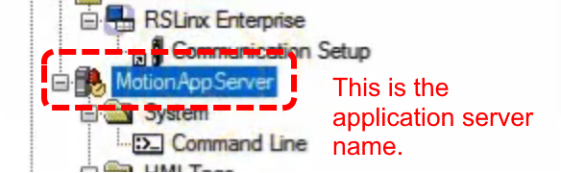
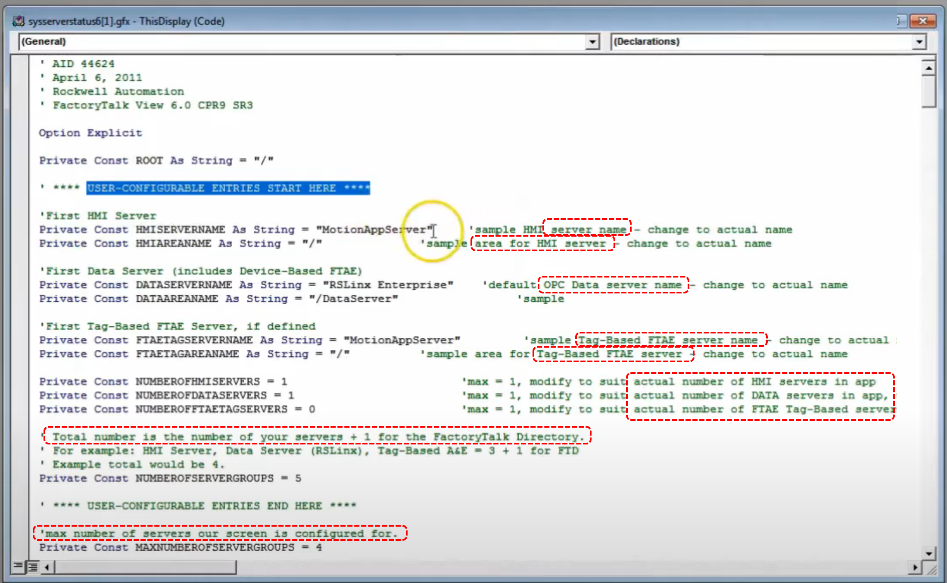
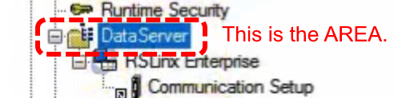

If using a second server you must fill in the below information as well.
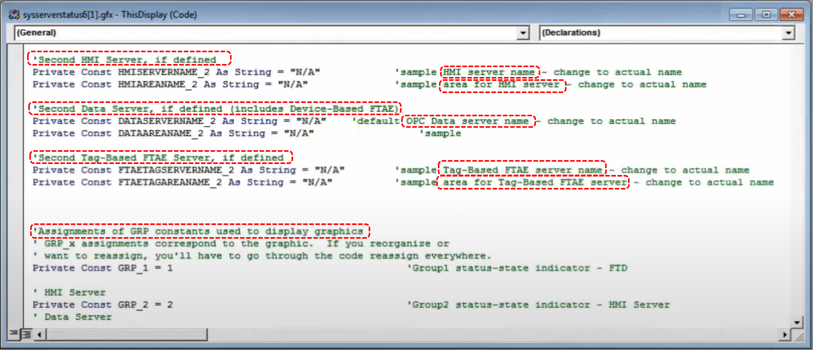

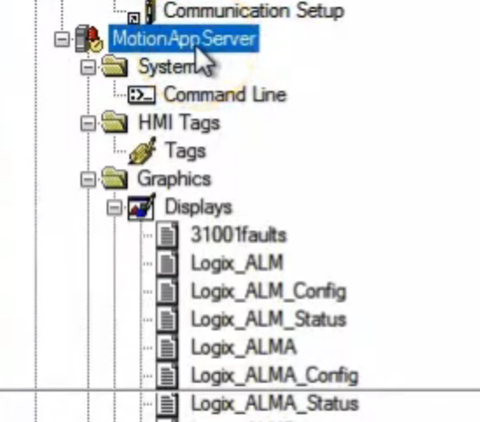
“MotionAppServer” is the HMI system we are creating our application under. This has to do with the “/” characters asked for in the application setup data above (such as HMIAREANAME”.

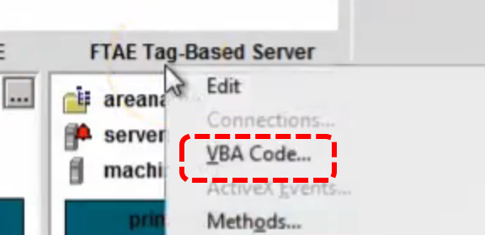

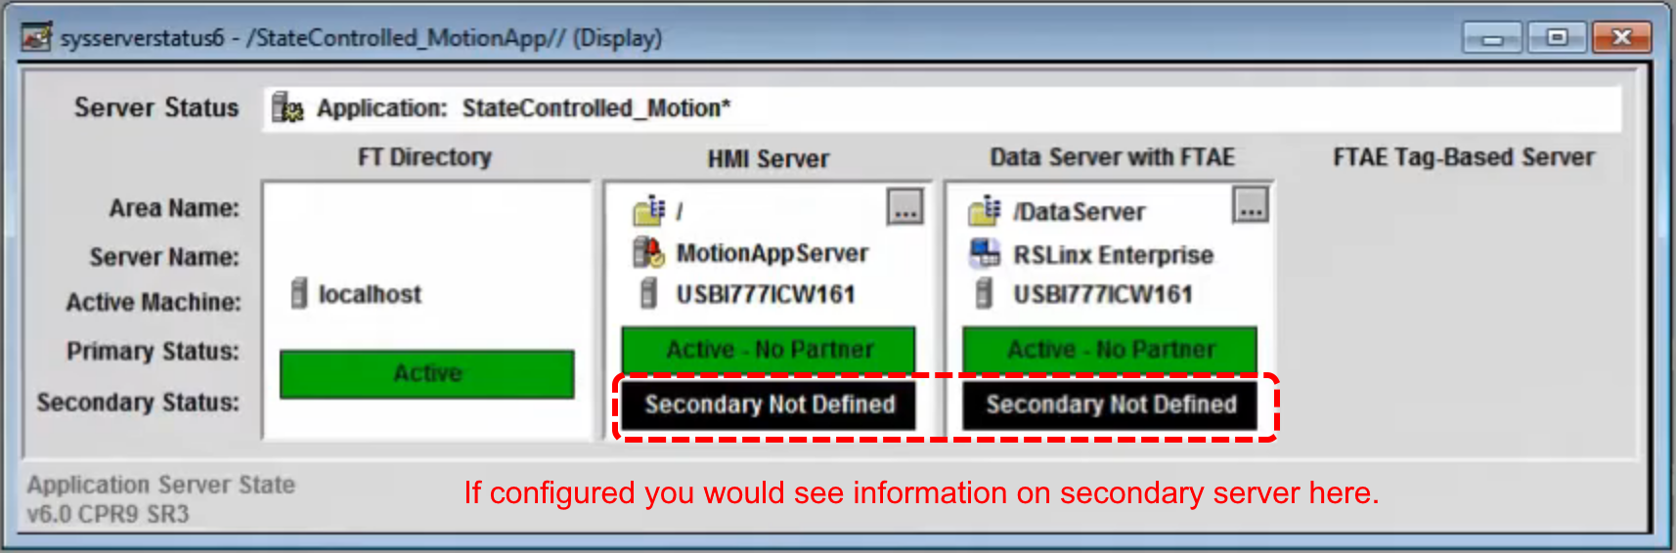

Often times you can use the Rockwell sample VBA program more or less as is and not be missing any functionality you need.

The purpose of the above screen is to allow you to check the full health of the system without going into shutdown and bringing up various other info centers.

Now we will add a small button to our navigation screen. Note how the list of actions comes up.

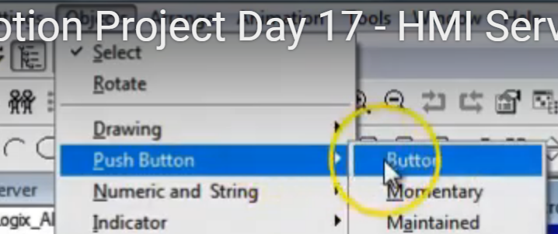

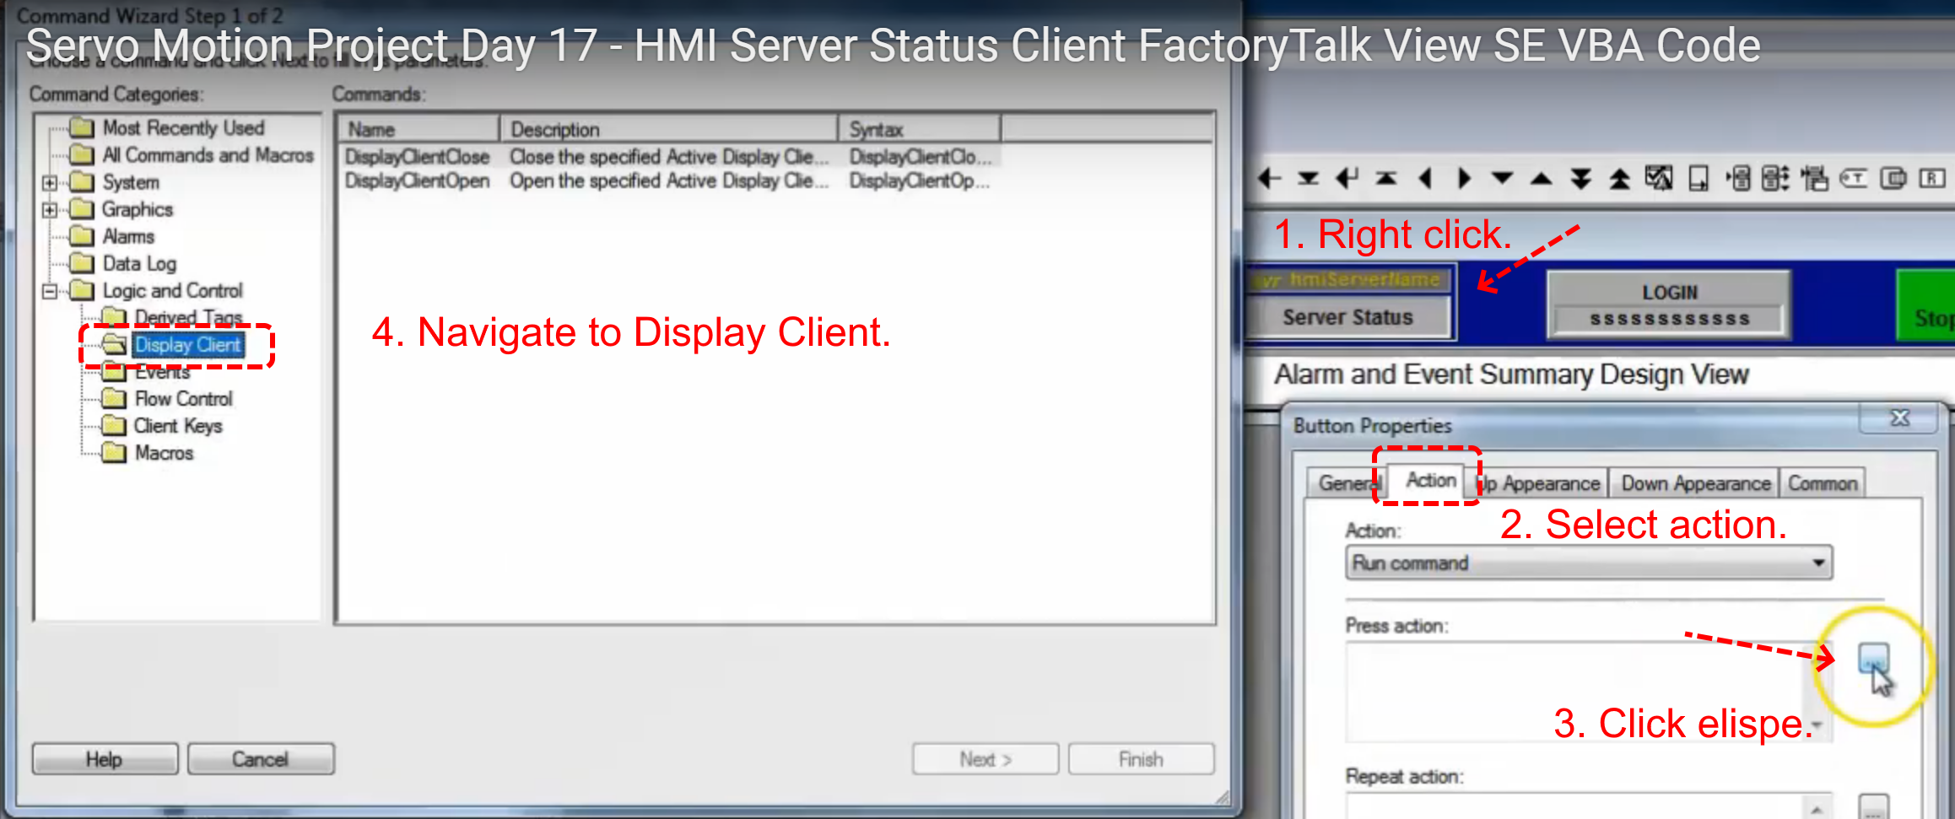

We will use the below item.
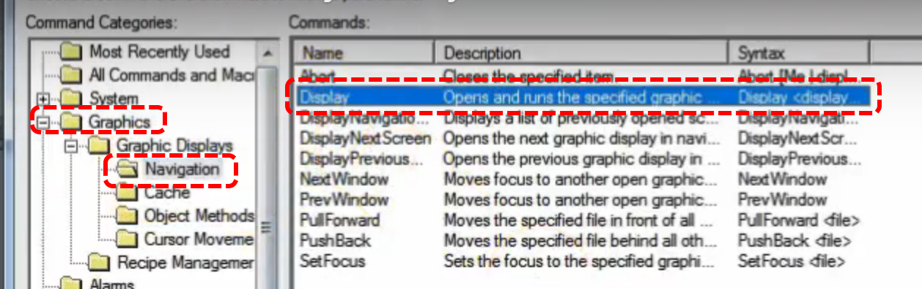

Follow this process… Click the elispe.
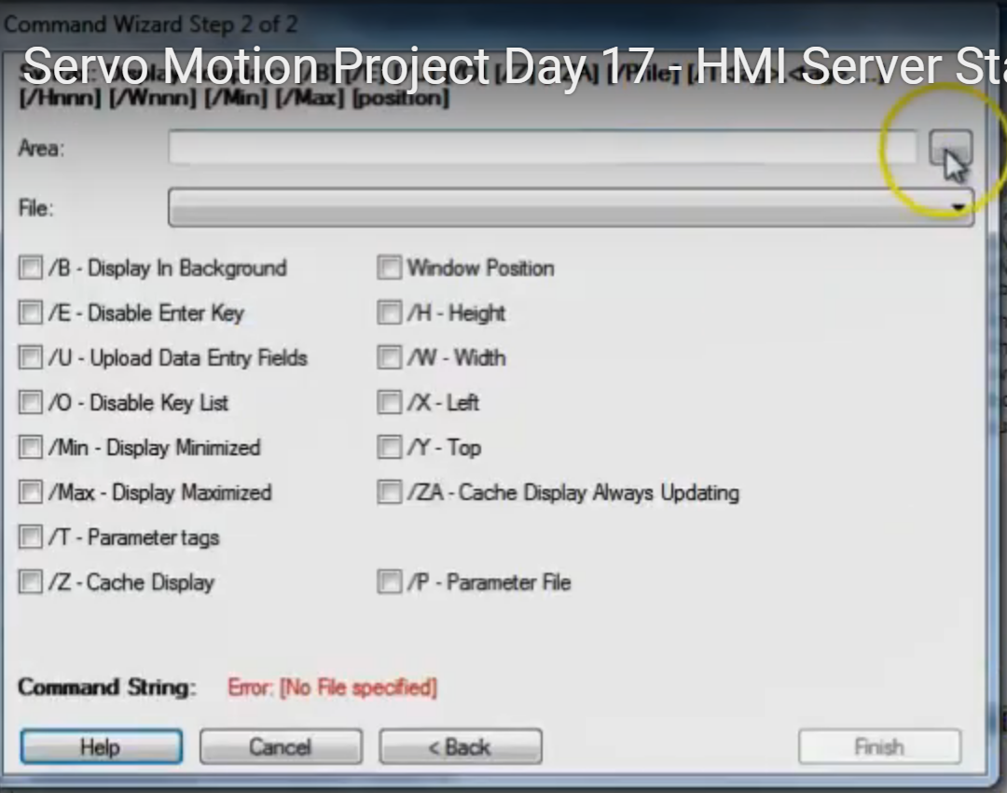
Ensure AREA is selected to server level.
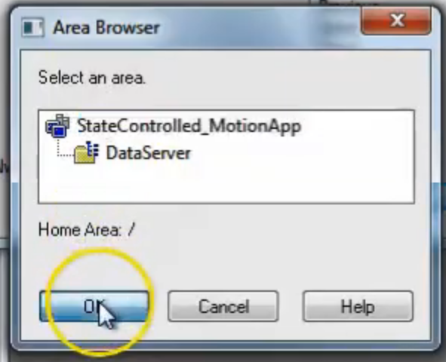

From the dropdown select the screen you want to bring up then click finish on that dialog.
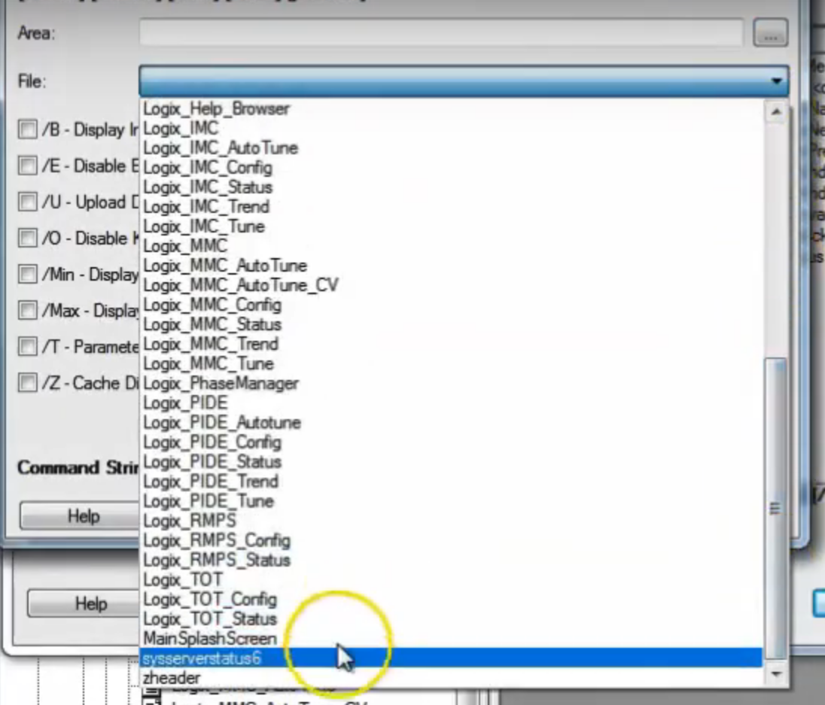
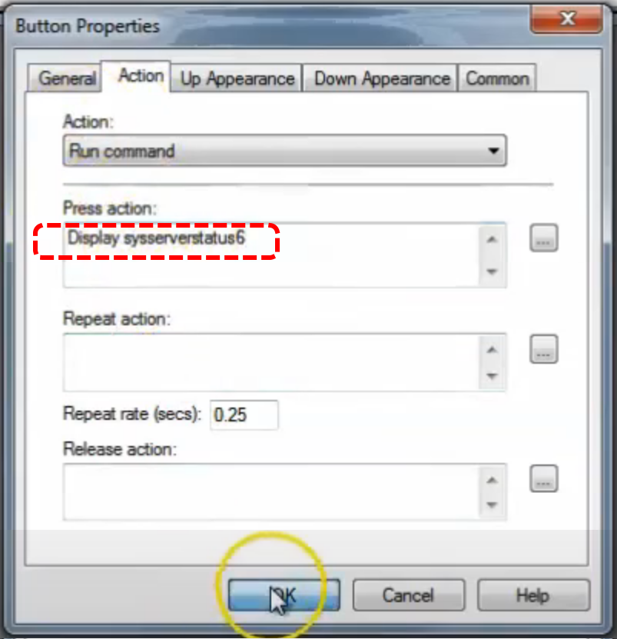

Click OK to finish.

Next we will add a footer screen.Now we will build the client and see what we have so far. Double click on Macros | Client Start to examine the macro.

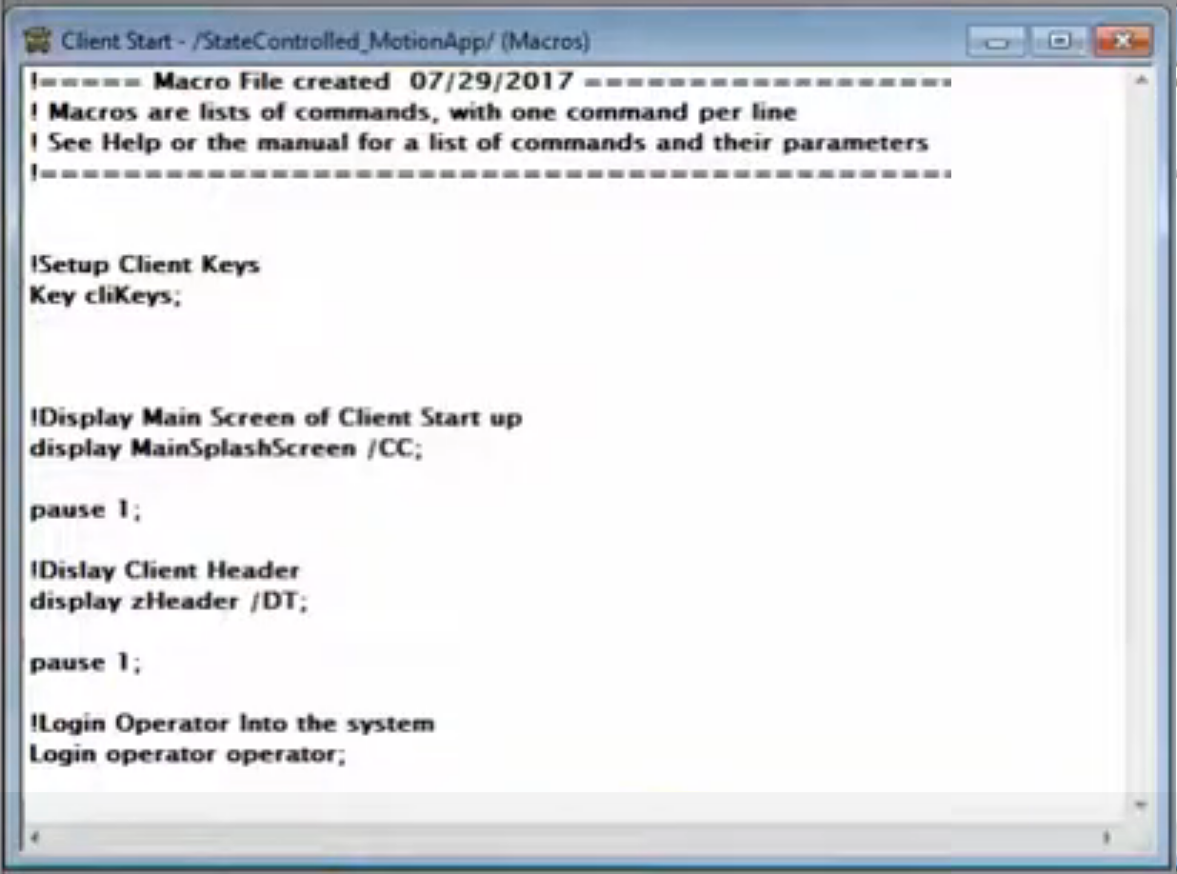
Macro looks good. Now build by pressing the menu bar icon:

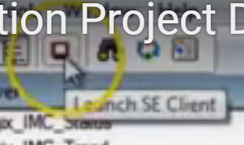

In the dialog click on NEW.
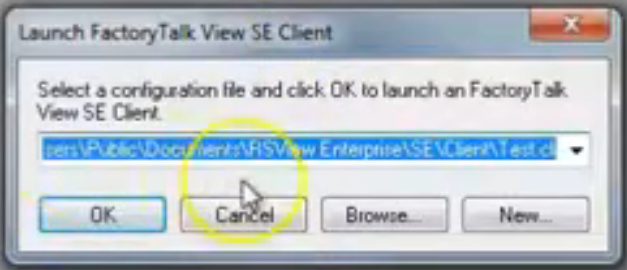

Click New again…

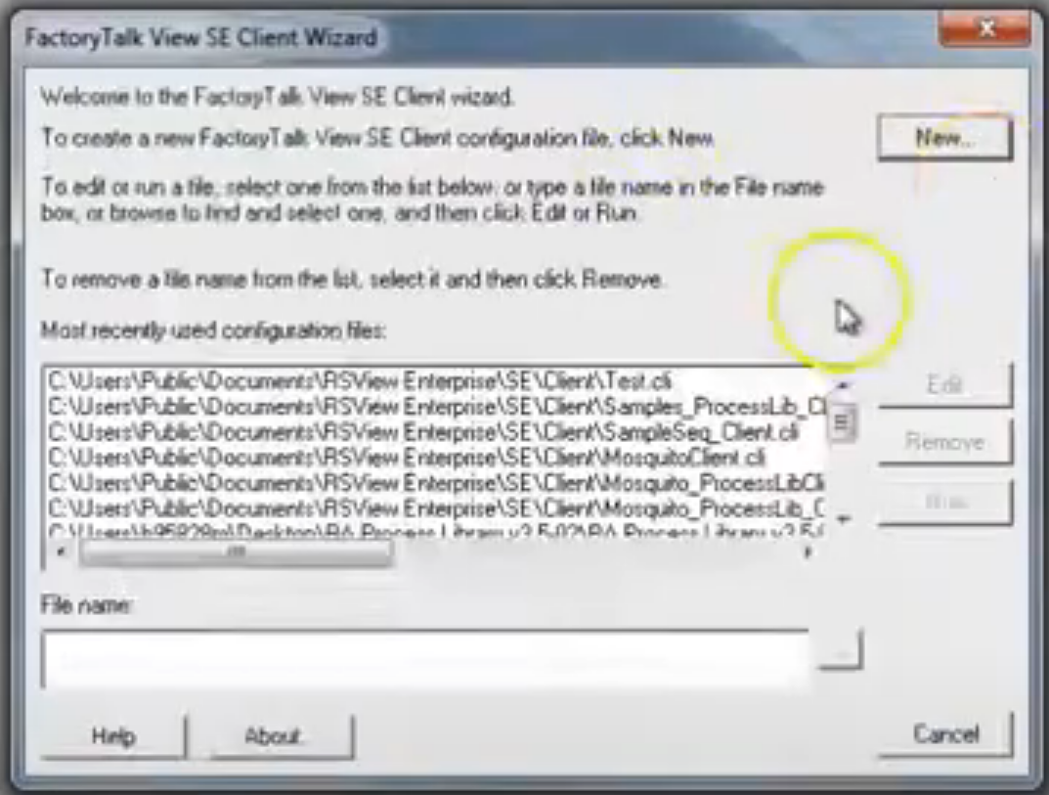
This is the New Client dialog. Type in a name for the new configuration file. Then click Next.
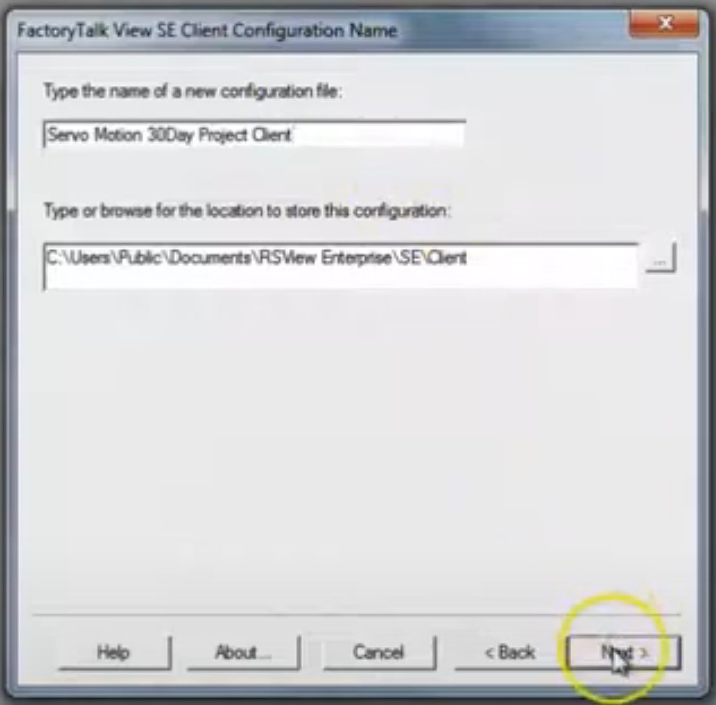

Check the network model, we are using Network Distributed.
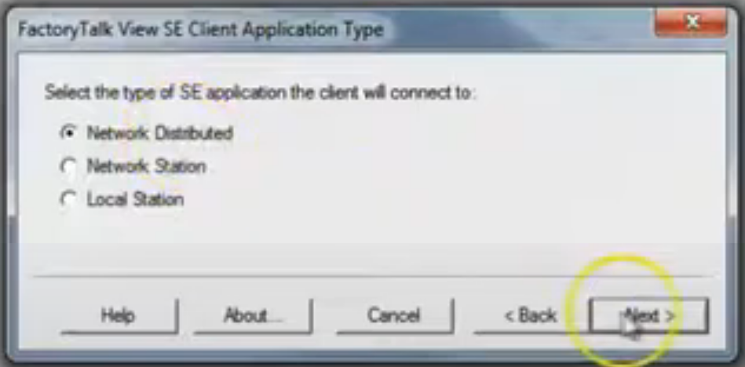

Next we are specifying which server we want the client to attach to, in our case the StateControl_MotionApp. Click Next.

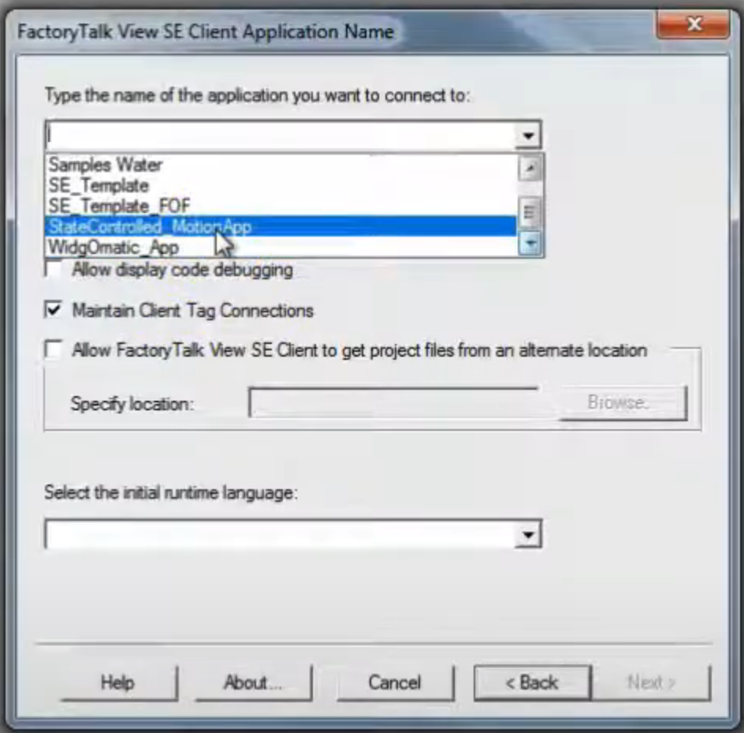

Click the ellipse on the AREA entry. You want to select StateControlled_MotionApp, it has the data server under it. If you select Data Server there is nothing under it so the application will not work.

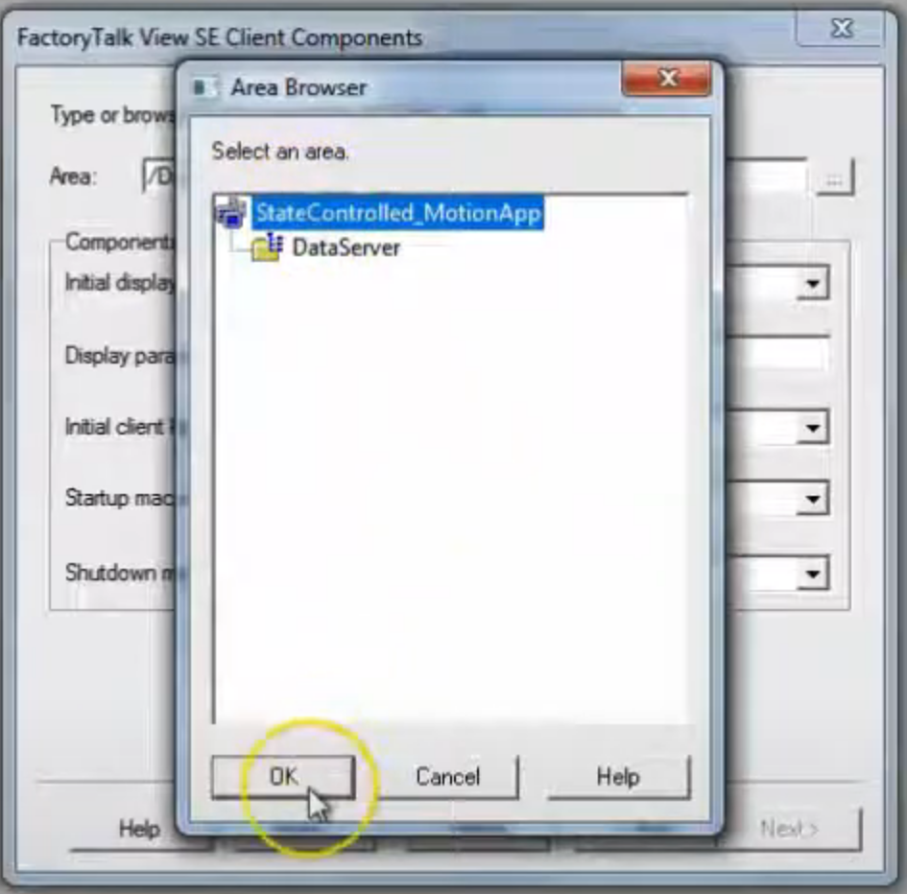

The forward slash represents our choice (defined in VBA app). Also fill in client key and startup macro. Others are optional.

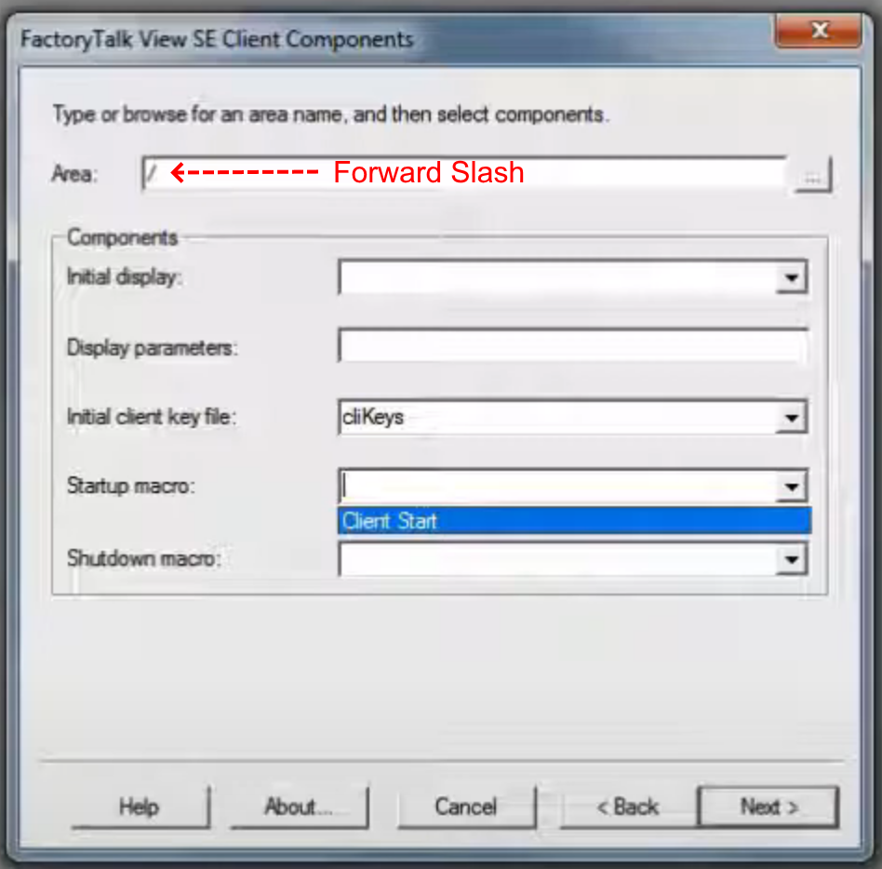

Click Next. Now uncheck Title Bar option. May want maximize as well. We’ll use diagnostics for now.

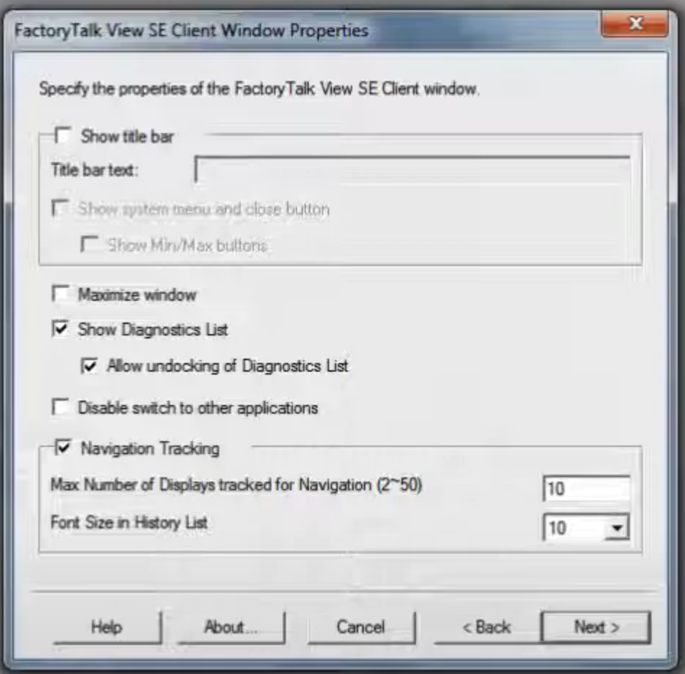

We won’t use Enable Auto Logout.

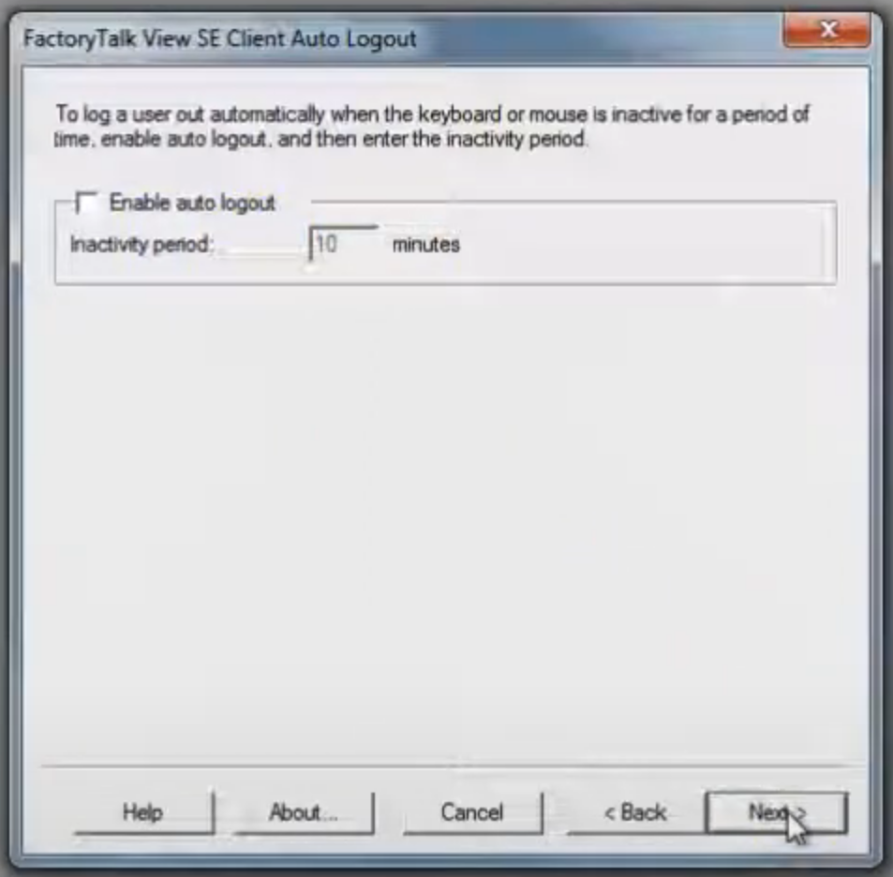

In this dialog we can click Finish.

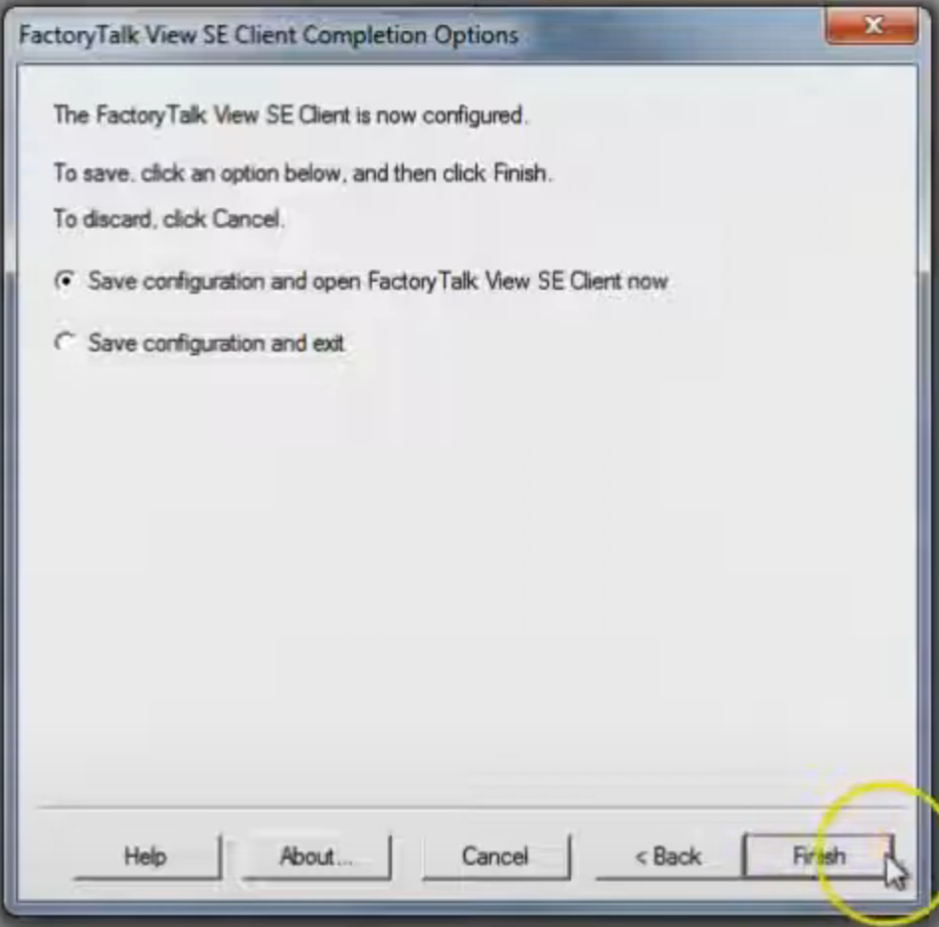

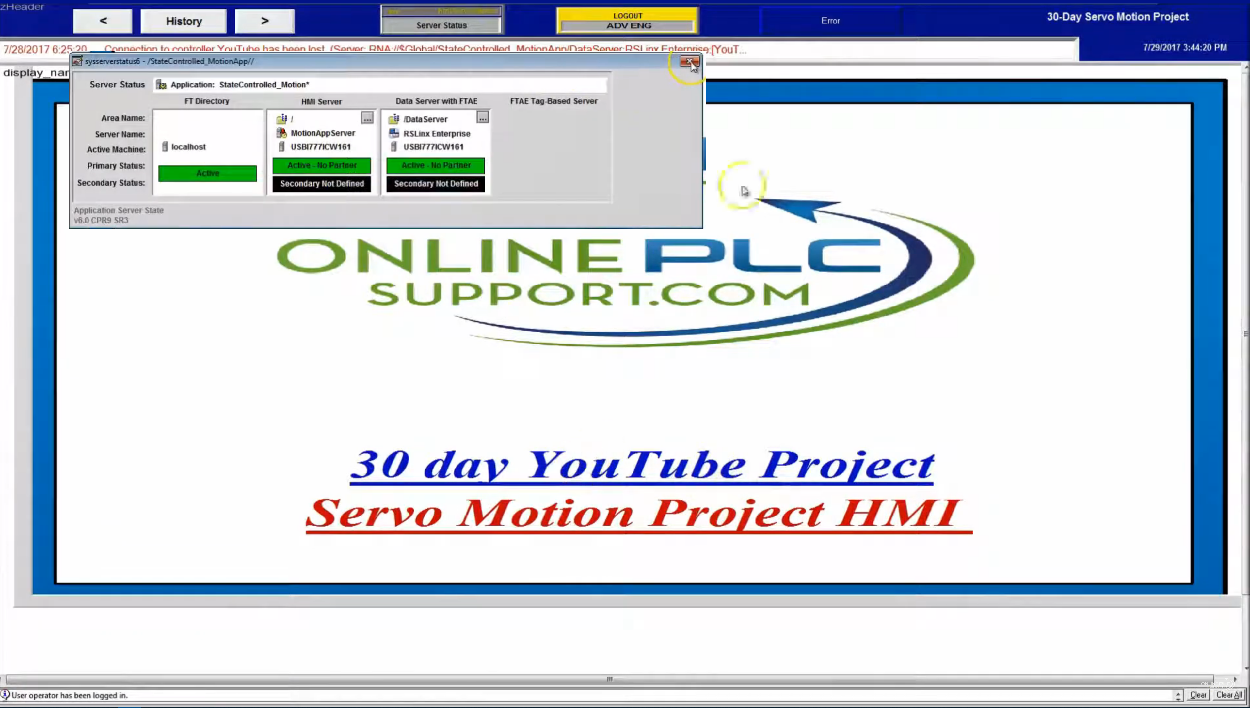

Client keys CTRL + SHIFT + Q will shut down the application.

Now we want to build a shortcut for our application.
Open the Communications Setup menu item.

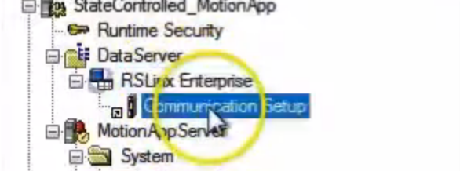

We had configured YouTube earlier.

On the PLC side we are using an emulator.

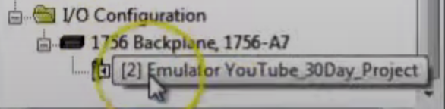

Click Verify in the bottom right corner then click OK.
Double click the “Machine Stopped and Reday” button to bring up the button properties, go to the Connections tab.

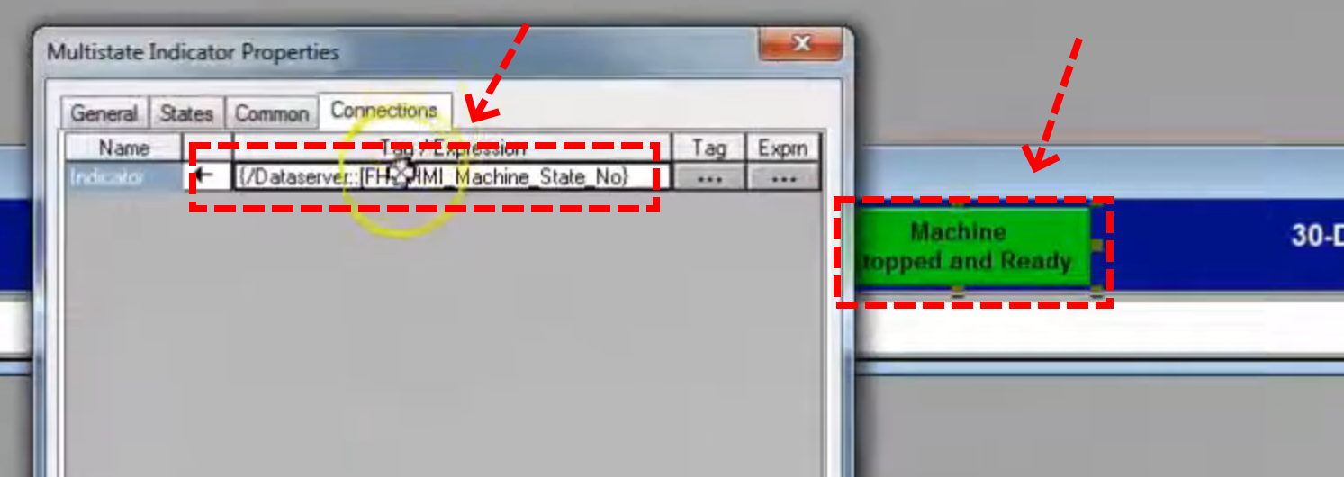
Change the string to what is shown below.
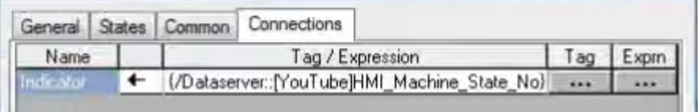

Click Apply and OK. Save and close the navigation window. Click the Launch Client button.

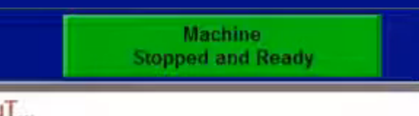
Button is working (making comms), displays the state we are in. When we start the PLC app and change the state we see the button properly picks that up.

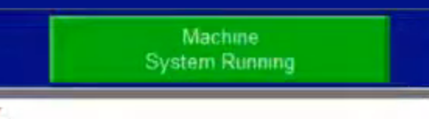
Now we’ll make a new screen.
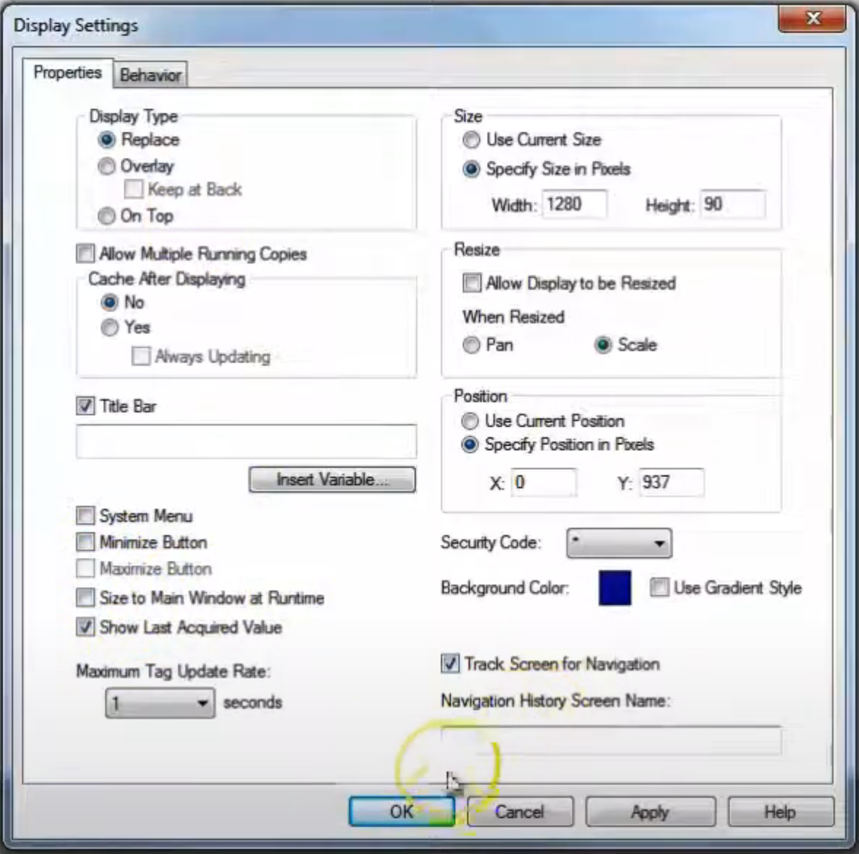
Name and close the screen.
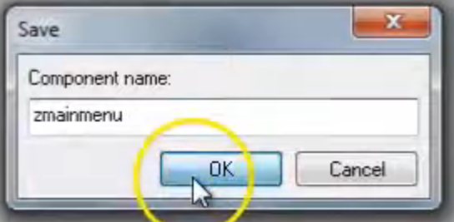
Modify the macro to add display zmainmenu on the bottom.

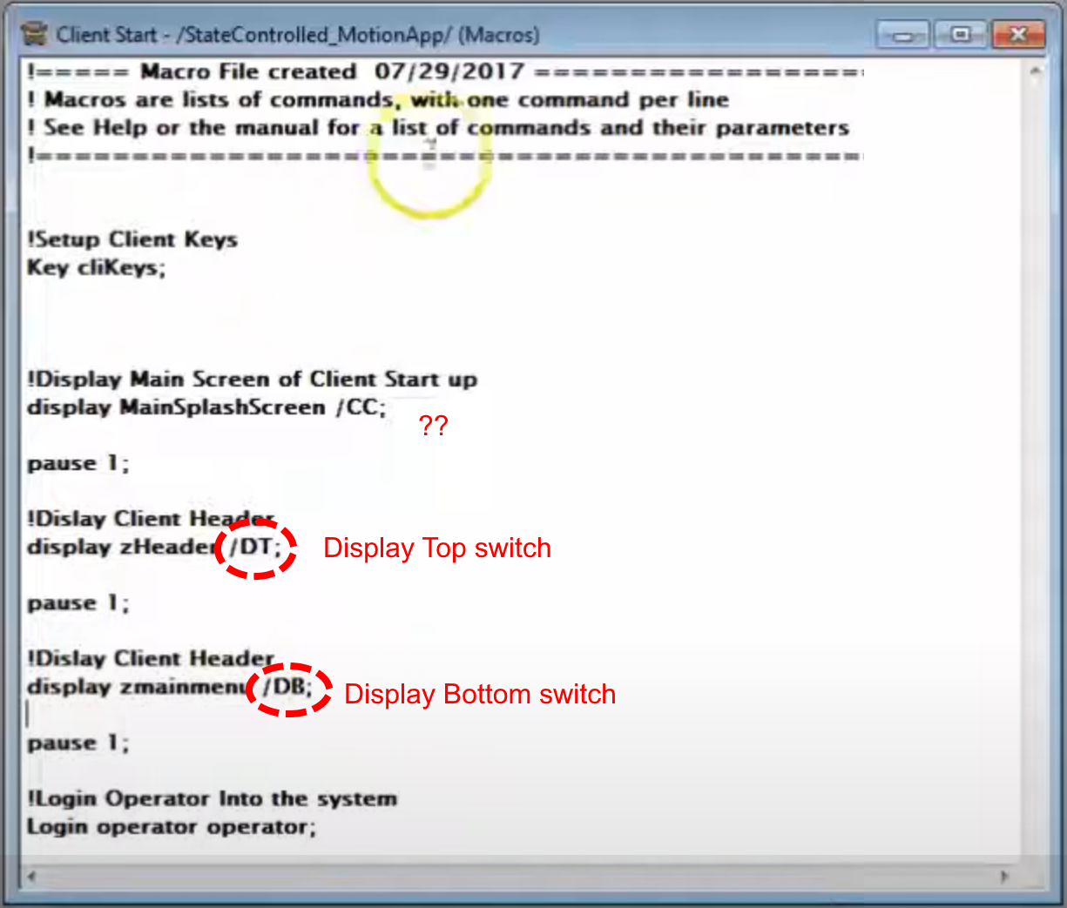

Now we will make some screens.

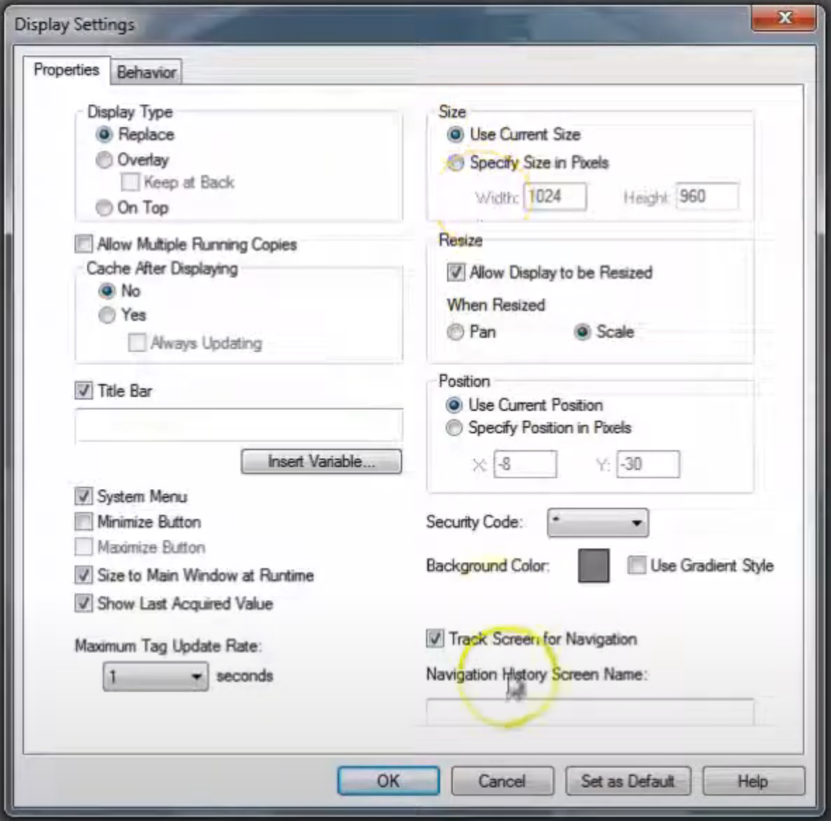

What we are doing here is showing our axis as a web and displaying the average velocity of each axis on its drum.

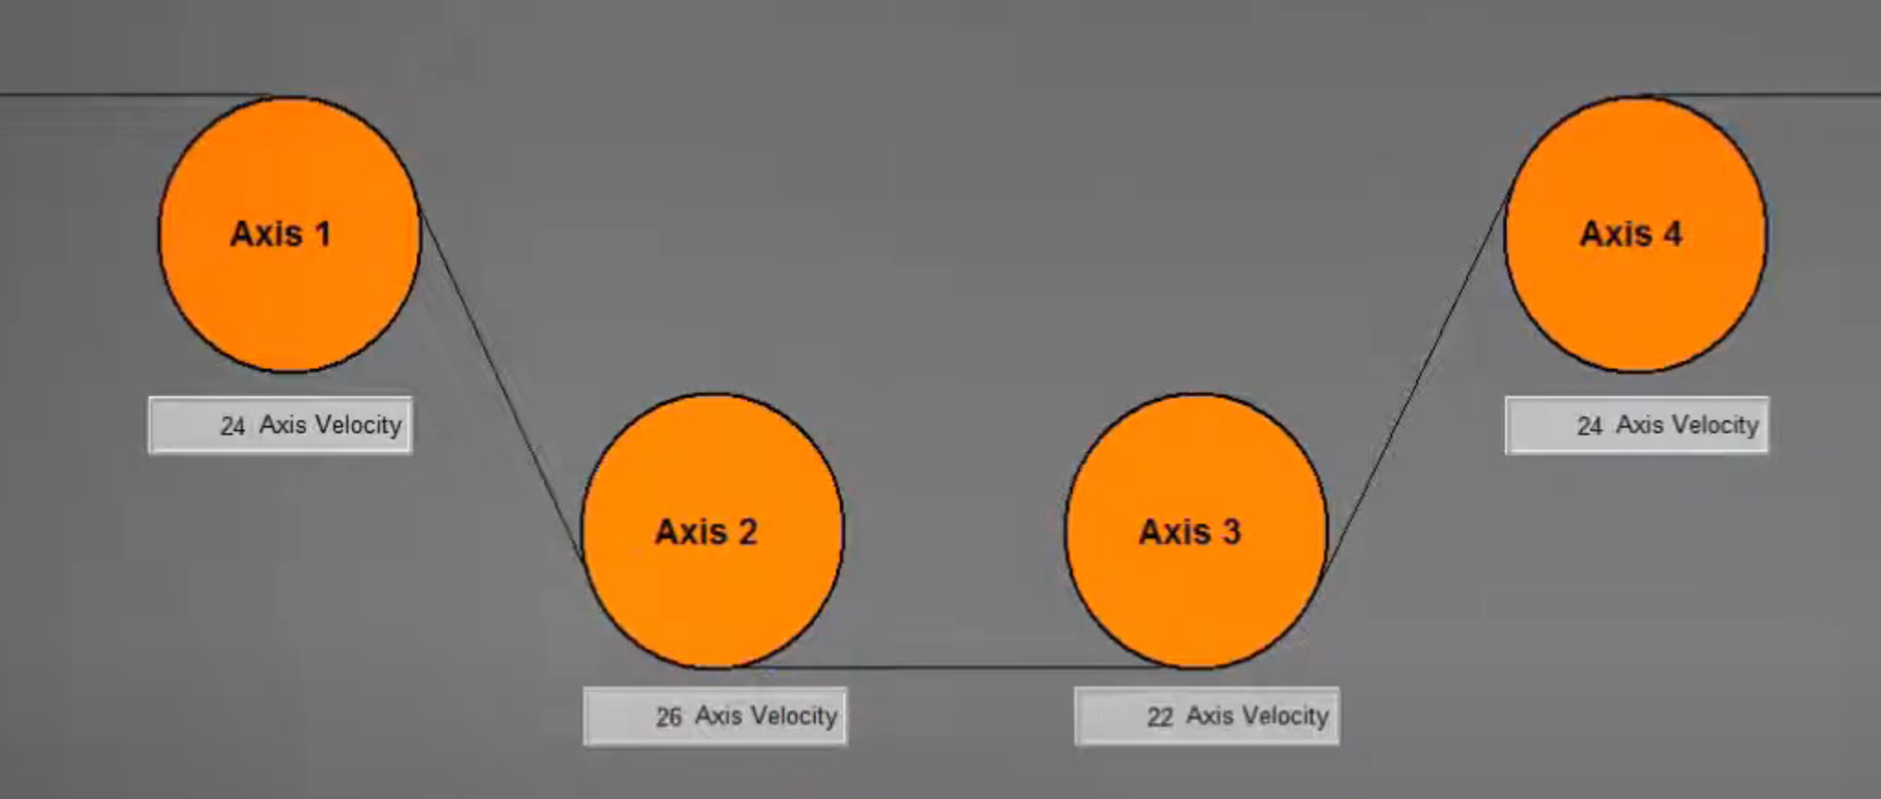
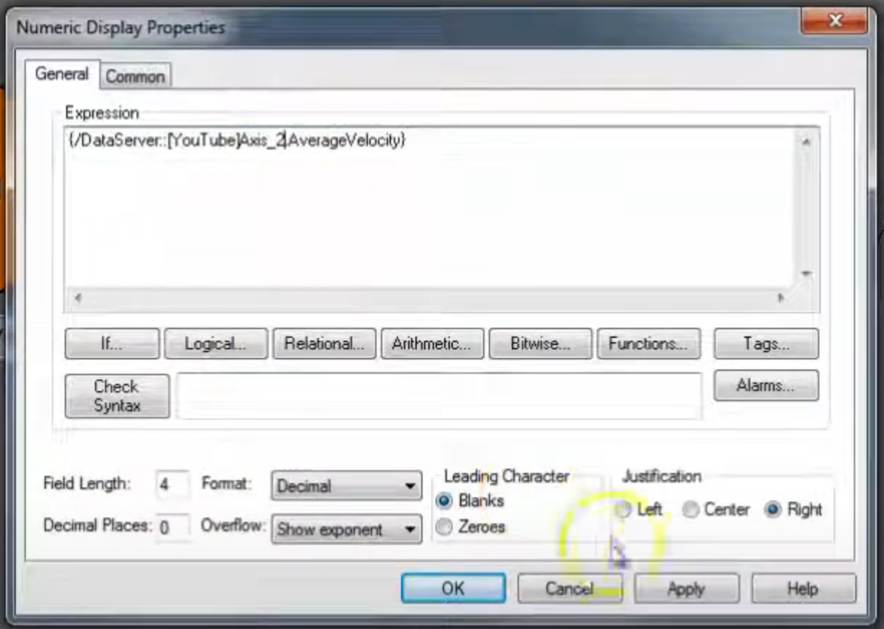

Now we want to add an axis start/stop button. This item is from StateMachine_Main | MachineState_Control.

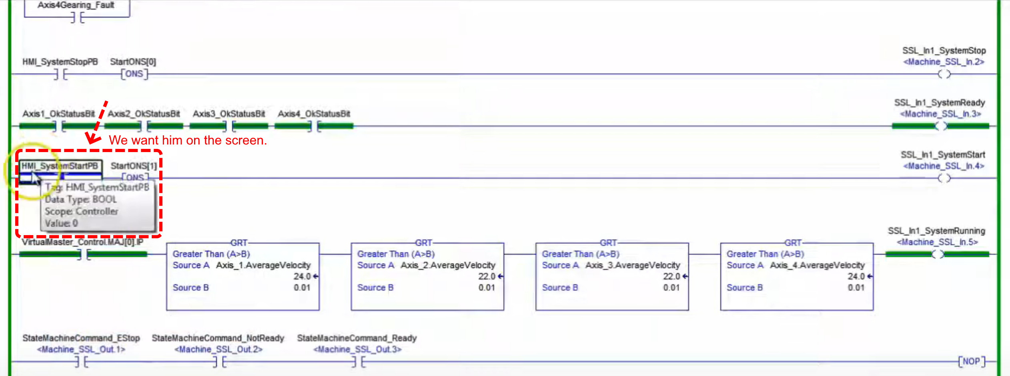

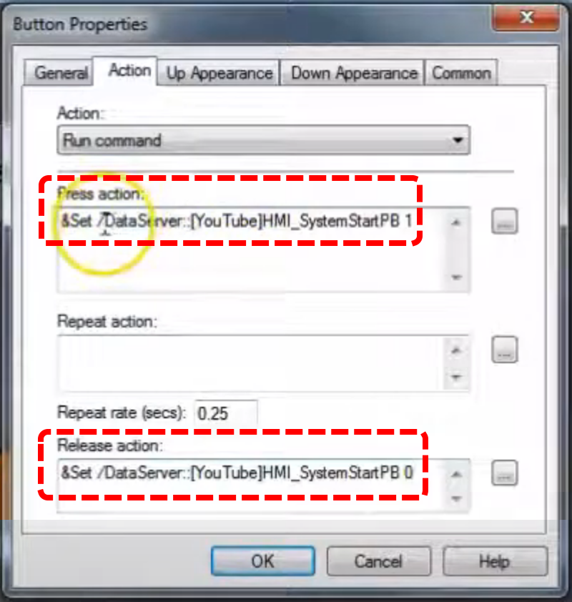

Let’s review the process for bringing up the tag select dialog.

Double click the button. Up Appearance tab, fill in Caption.
Select Action tab. Clear out Press action of any previous entry. Click ellipse.

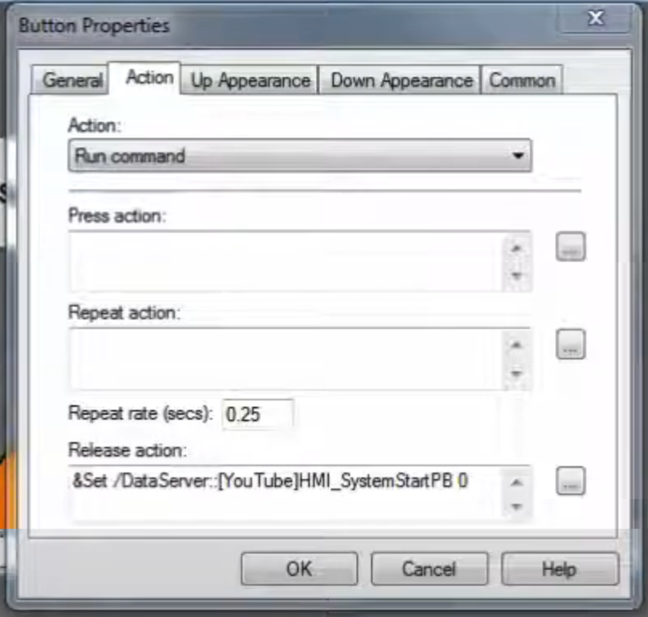
We want the SET command.

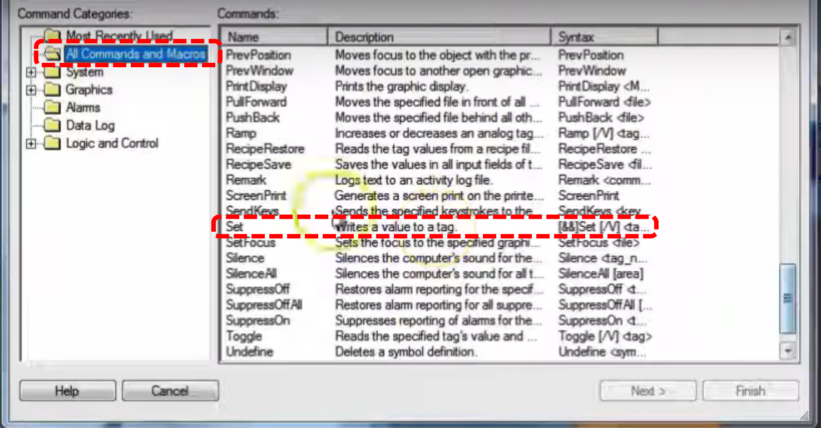

Click on ellipse.

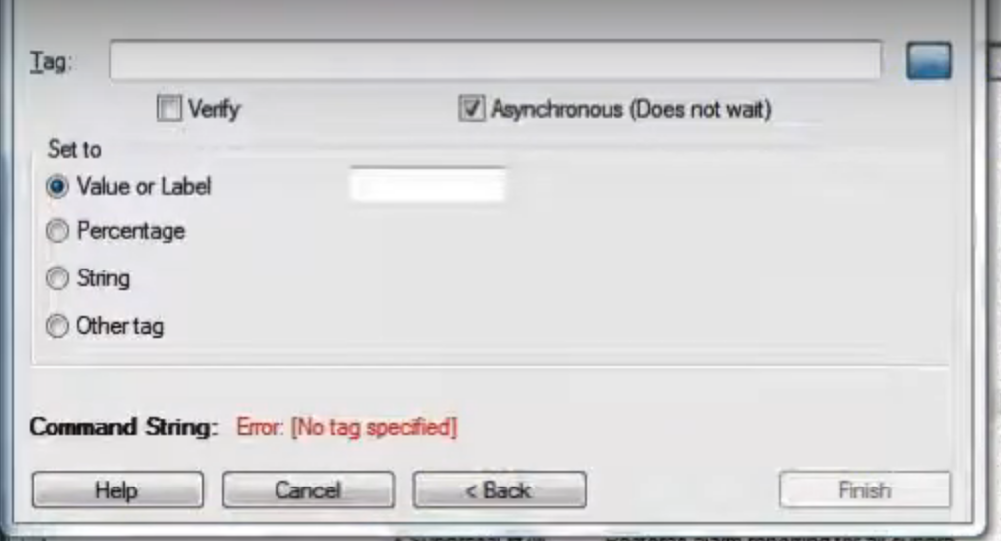

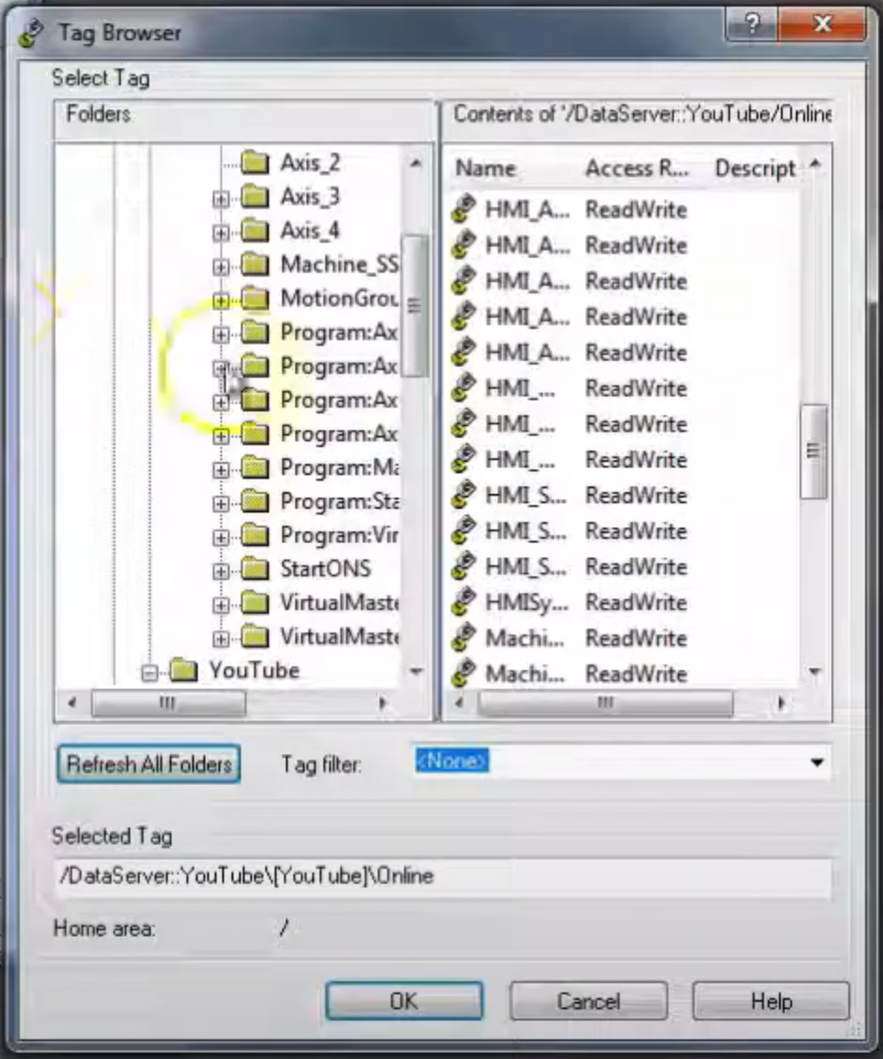

Select this tag

Press Action Command: this gives us a 1 second hold of the pushbutton effect.

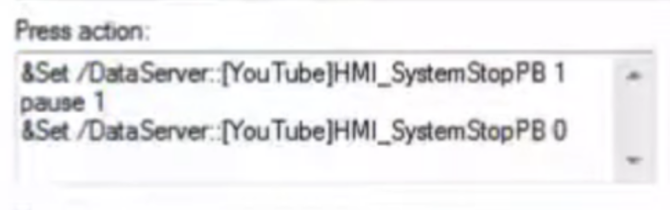
Release Action is blank.

Bottom number is gear draw.

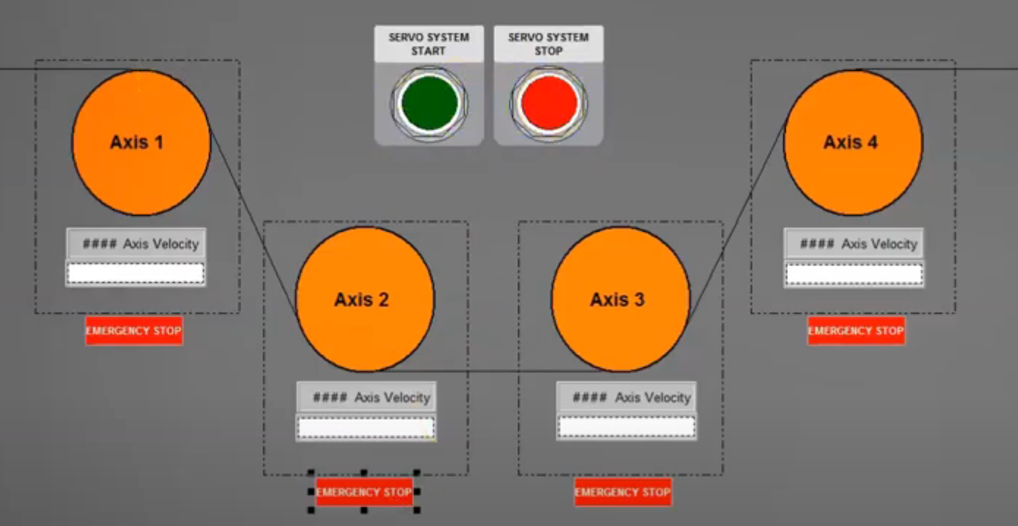

Adding an E-Stop button.

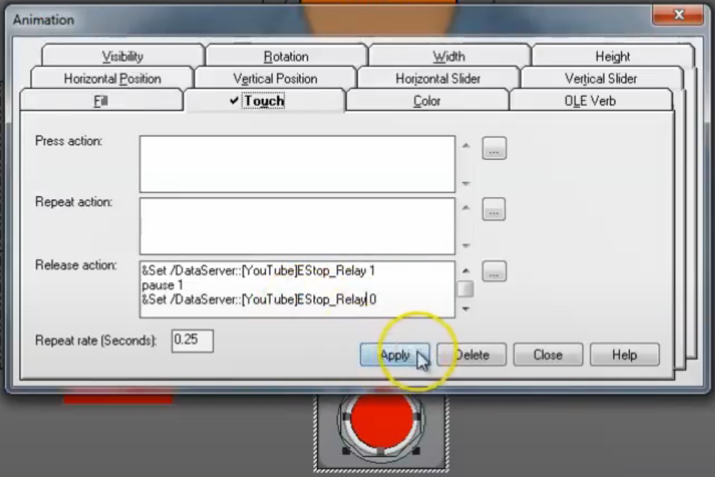
Want to add alarms and events. Recall our header screen has an A&E banner.

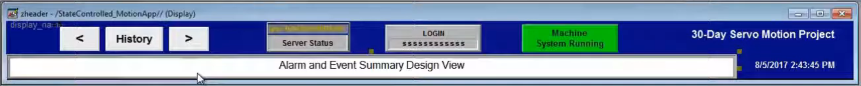

We want to use an ALMD instruction in ControlLogix. Create a new routine under MachineControl_47ms|MainProgram called SystemFault.

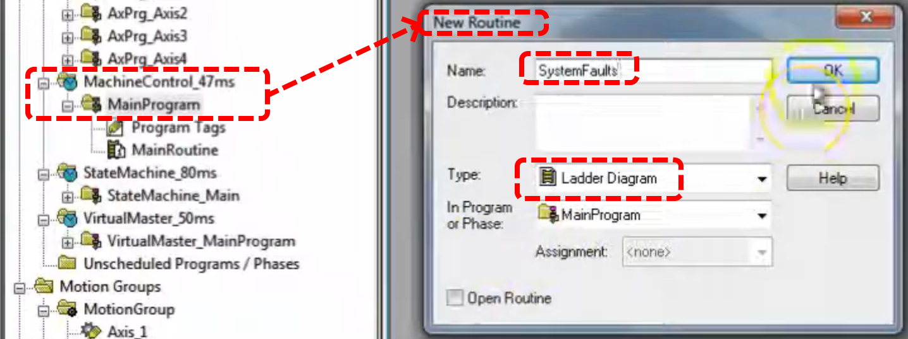

Remember to add a JSR in MainRoutine to call this function.

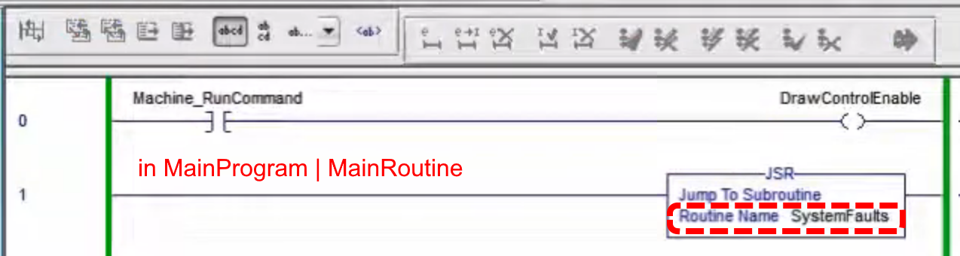

Now the idea is to make alarms for all the faults we capture. Two types of alarms, analog & digital.
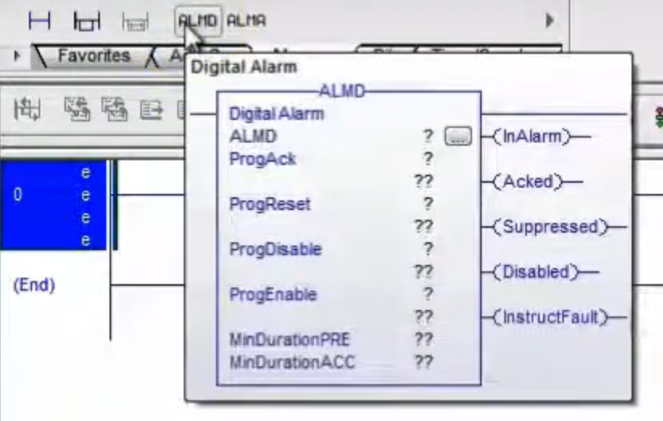
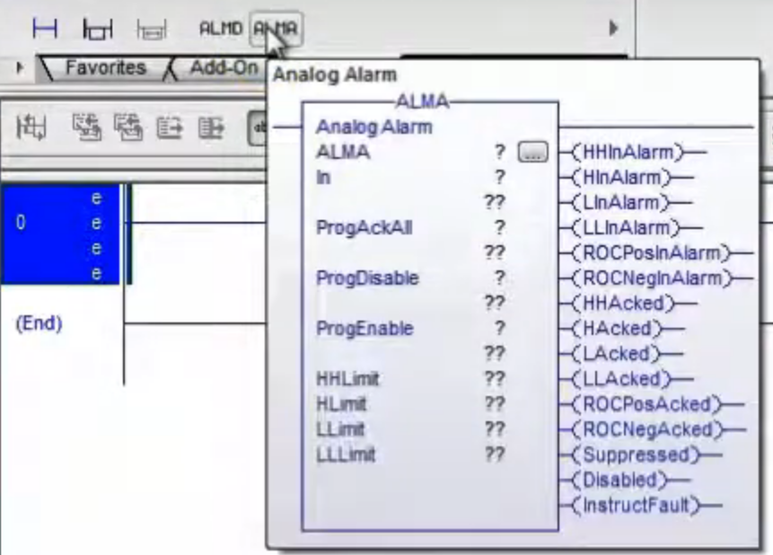
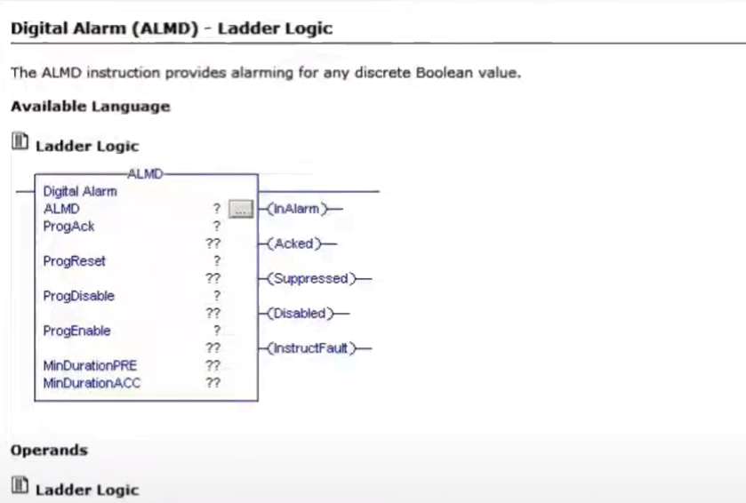
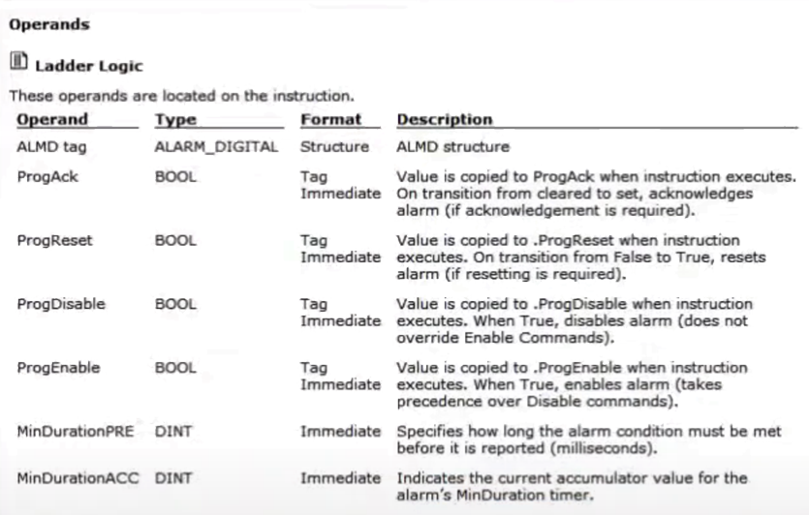
Need Alarms Enabled in RSLynx.

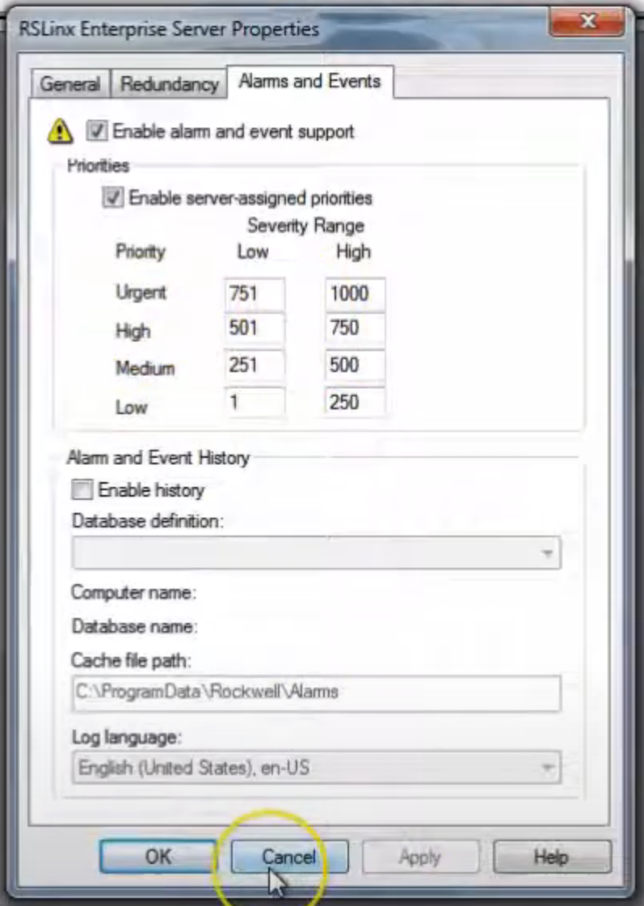

On the communications panel of FactoryTalk View you must also have alarms enabled.

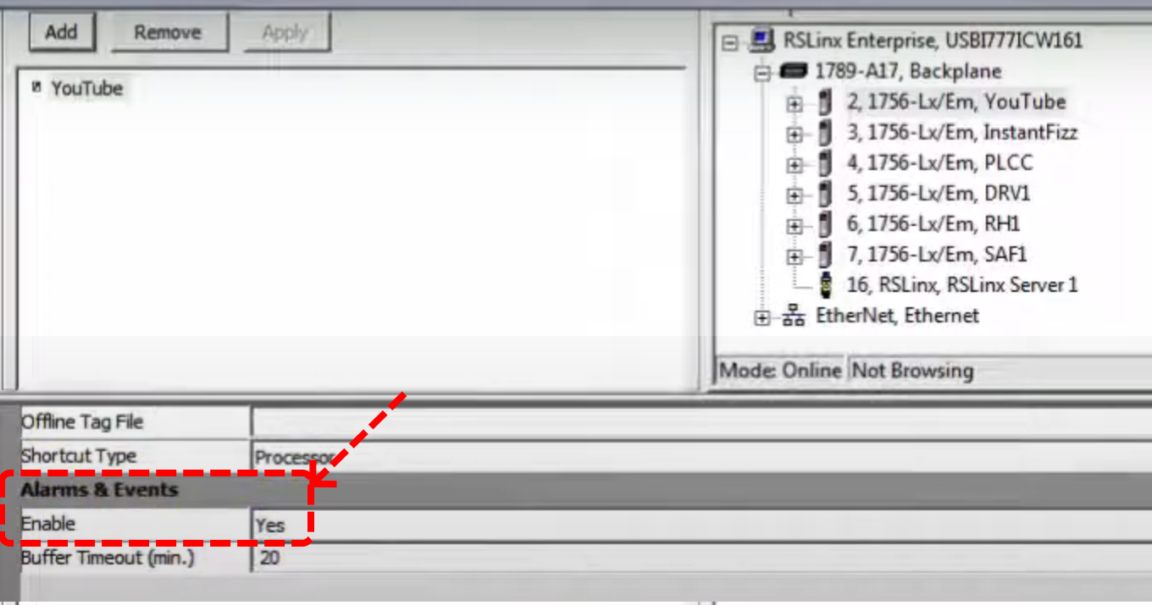

Now back in Logix Designer create a new tag for the first alarm, be sure to check “Open ALARM_DIGITAL Configuration” before clicking create. It is a controller scope tag.

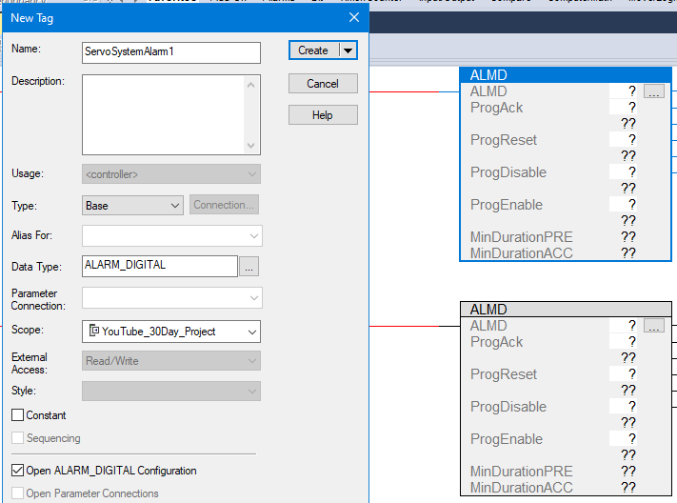
Enter the Severity, this is E-Stop so it will be 1000.

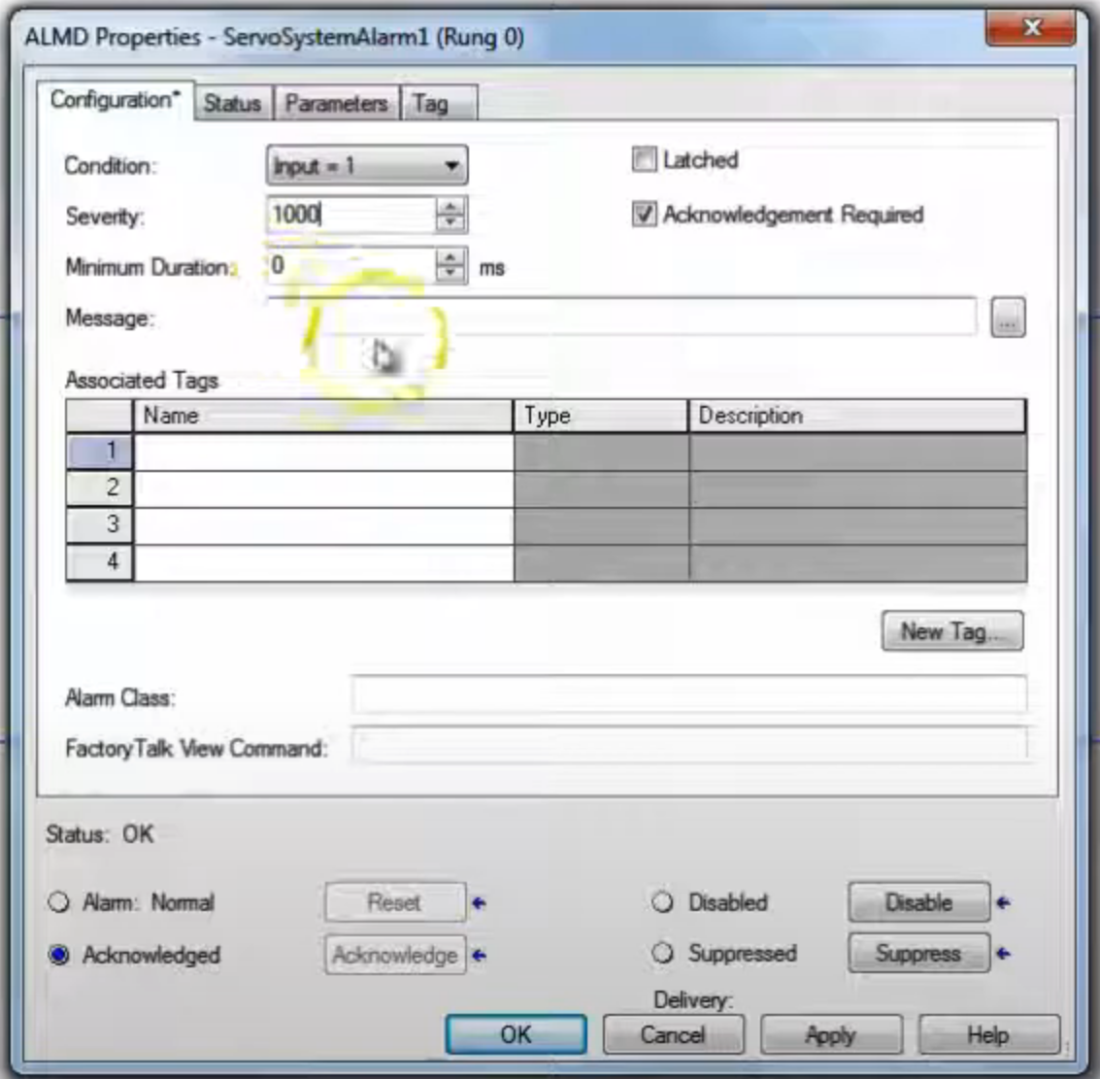

Click the Name field under Associated Tags and click New Tag, create as shown below.

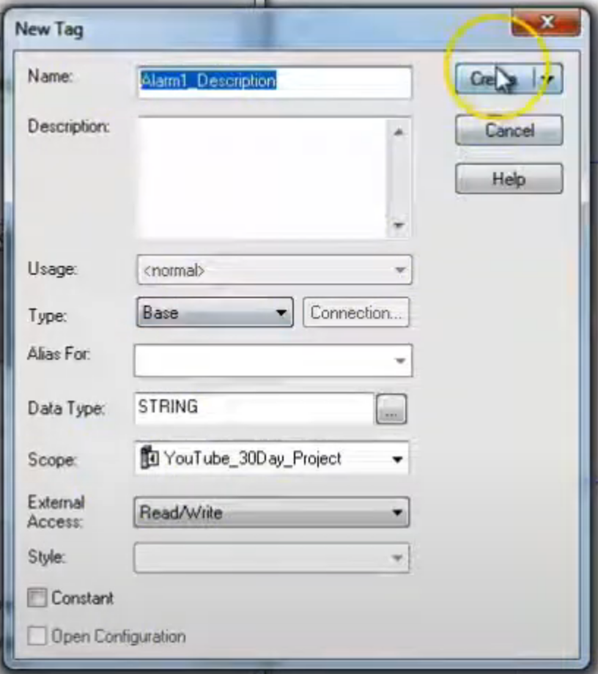
Click ellipse on Message.

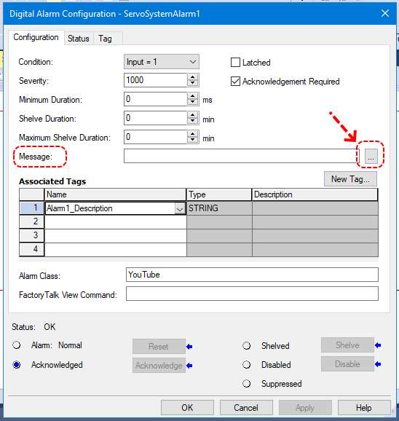

Select “Tag 1 (Alarm1_Description)” then click Add and then click OK.

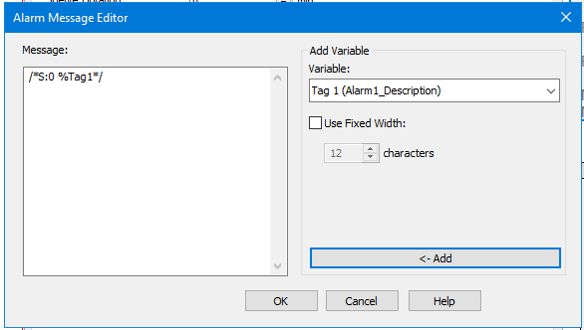

Must set Alarm Class equal to the shortcut created for comms in FT View.

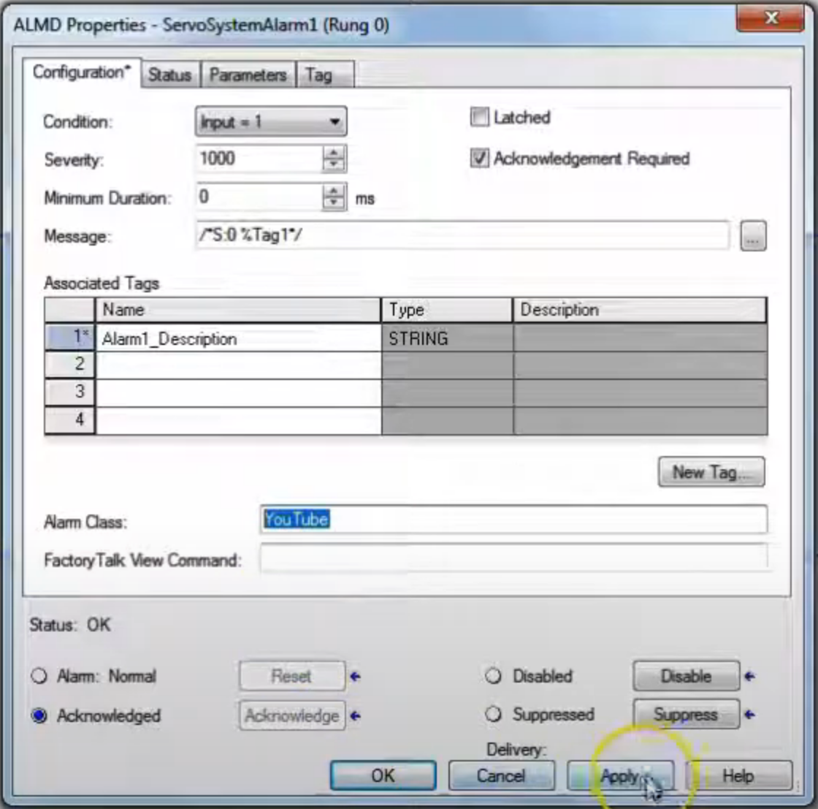

Do the same for remaining axis status bits. Use 750 severity for non E-Stop.

For now set all the ALMD fields equal to zero.

Add the contacts to each rung as shown below.
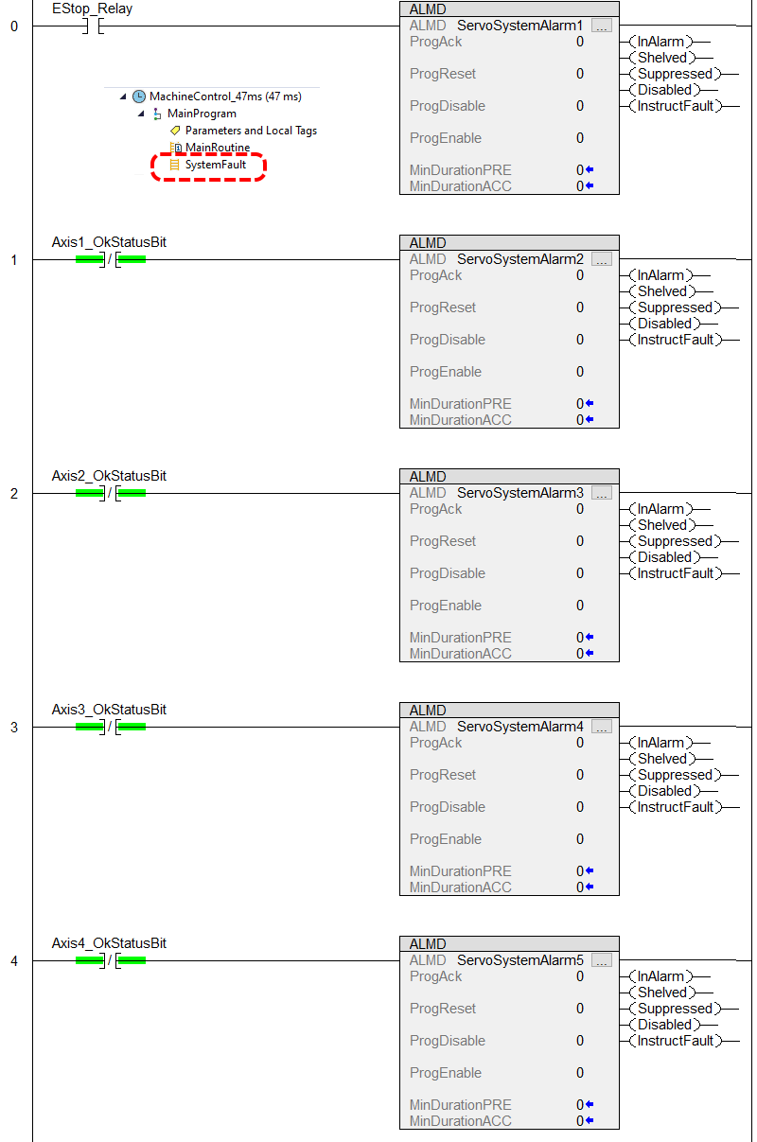
Now we will populate our alarm description tags with the data they need to describe (Value field). Look them up in controller tags and click the ellipse.

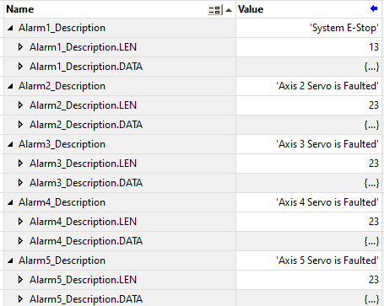

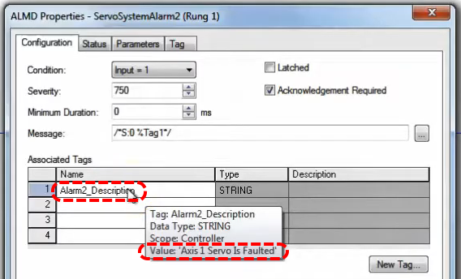

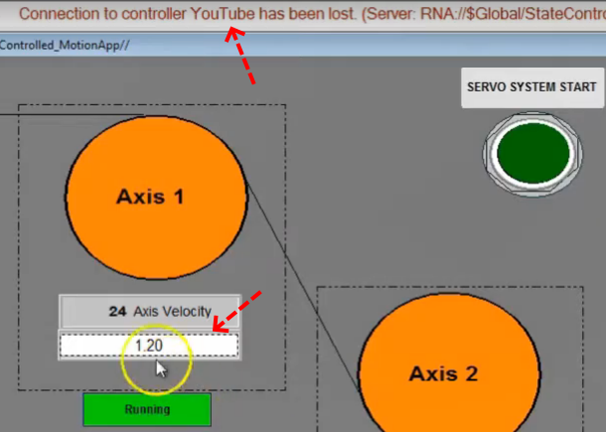

Now when we run our app we get a message up top saying the connection to the controller is broken even though we can see that we have comms. An adjustment needs to be made. We have an RSLynx problem (there exist a RW tech note on this problem). Go to control panel, click on Administrative Tools, double click on Component Services, then Services (Local), scroll down to RSLinx Enterprise, right click and Restart, do this while the system is active. Rebooting the computer will not fix this on non-server based systems. The status line should display faults now.

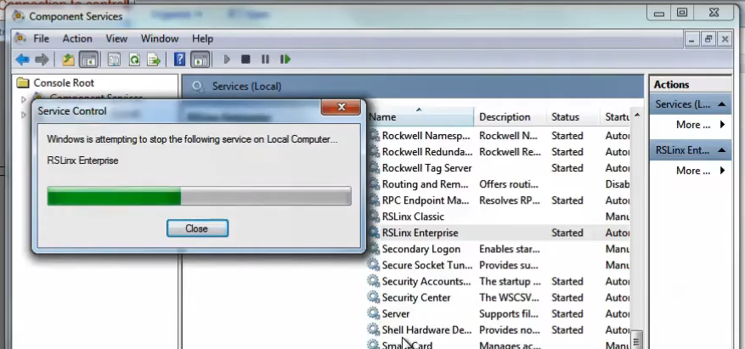

Now we want to make a fault screen active. Open our fault screen…

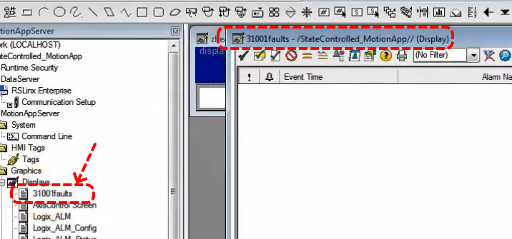

Right click and select Delete so we start from scratch. Now from menu bar select Objects|Alarms & Events|Summary. Draw out the control. Helpful to change icon size to medium. Can adjust font size. The settings you see below should work.

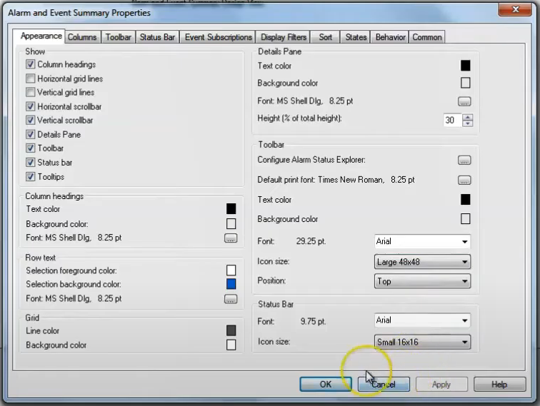

Do a quick test by clicking the run button on menu bar… 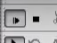

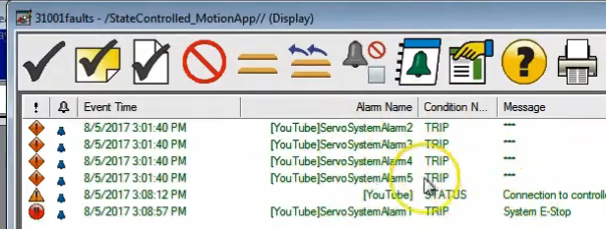

Close and save this screen. Open the Main Menu display, create a button to open the alarm screen.

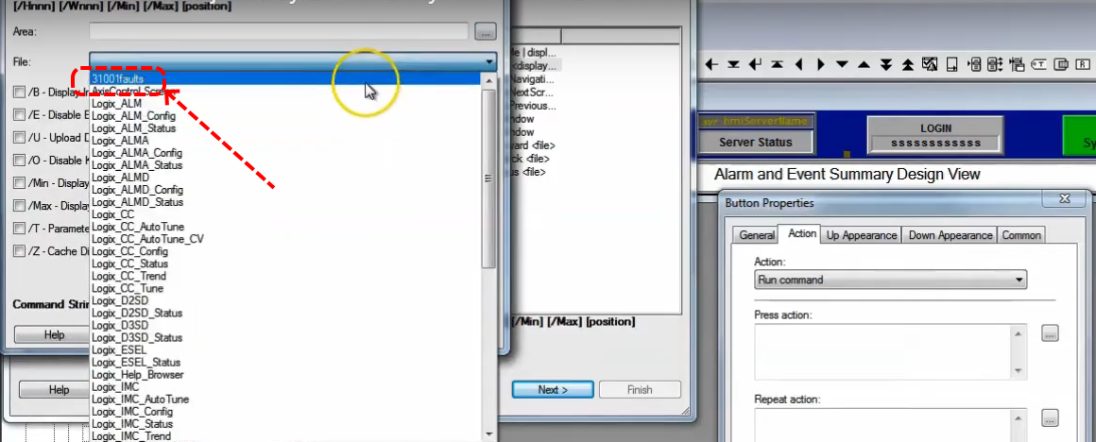

Now restart the client. Bring up the alarm screen. Click Acknowledge All (black check on white paper) and then refresh.

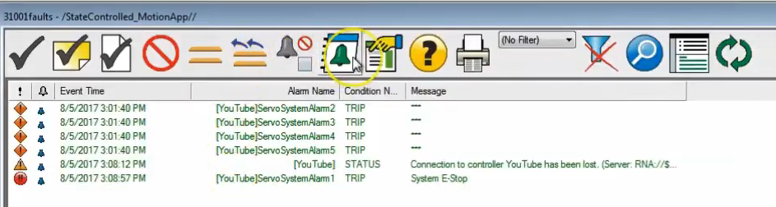

Now we see our status bar working. It seems that having an active alarm screen has allowed the status bar to access the alarms.

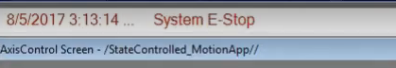
We can also see the condition on our alarms display. At this point we see all alarms working.

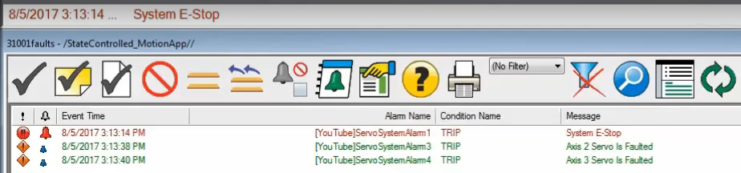

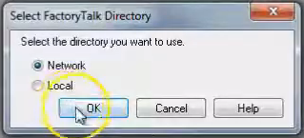
This is a basic demonstration of alarm capabilities

How to make a FactoryTalk View backup? Open the program FactoryTalk Administration Console. Select Network for the “directory you want to use”.

Select the application you wish to backup from the file tree.
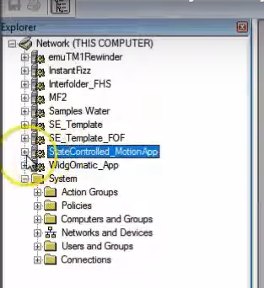

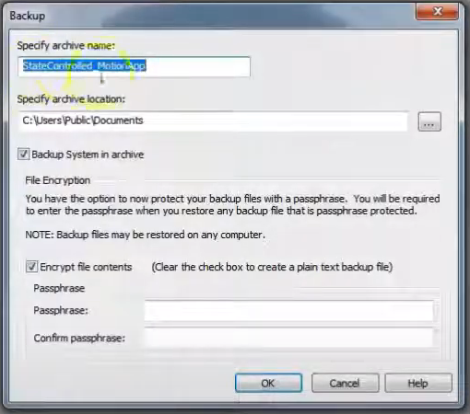
Right click and select Backup and click ellipse.
Here you select the archive location.

You can encrypt without entering a pass phrase.

Wait a moment for confirmation message.

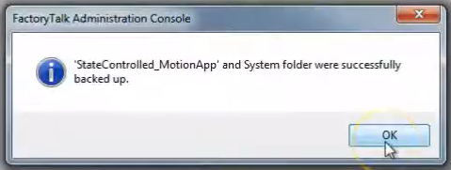
For a server backup (you’re application server) run the program HMI Server Backup & Restore.
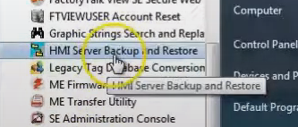

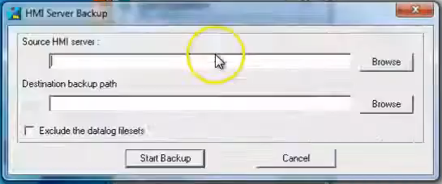

Select the source server and destination paths.
YOU MUST EXECUTE BOTH OF THESE PROCEDURES TO HAVE A COMPLETE BACKUP.

Now you must confirm your backup. Go to your destination and enter subdirectory according to the name of your server application (MotionAppServer).

Scroll to the bottom and inspect the size of file .sed, it must not be equal to 201, if it is you have a corrupt file/backup. There is a RW knowledge base article on this. If you have this problem close all programs and try again.

Also make sure you have files in your Gfx directory, those are the app screens.
Add a copy of your PLC application as well.
You also want to save a L5K version of the PLC application.

The L5K version gives you access to text based information such as version which you can change if you ever have to (risky).

Exporting to L5K and then importing has the effect of removing a lot of overhead associated with online edits. Also removes the cache files. Can be helpful.

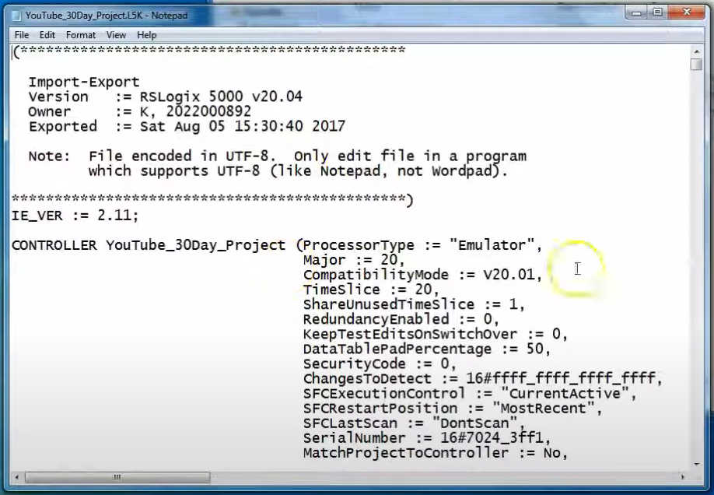
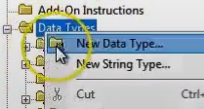
Now we will look at Produced & Consumed, aka, Peer to Peer Setup. We will produce/consume our start button from another processor. We begin by creating a user defined data type (UDT) which will handle the data exchanged.

We’ll just use a bunch of bools to demo.

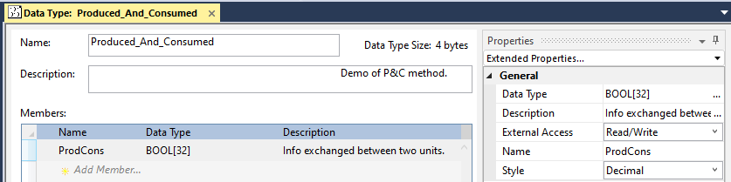

Now export the P&C data type and import it into the other processor. Then, on both machines, create a controller tag that has this UDT as its data type. This is NOT an array.

Now right click this variable and select properties.

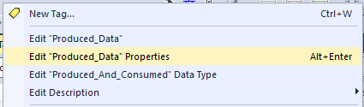

Set the data type to Produced.

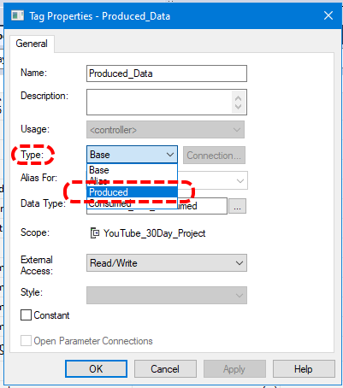
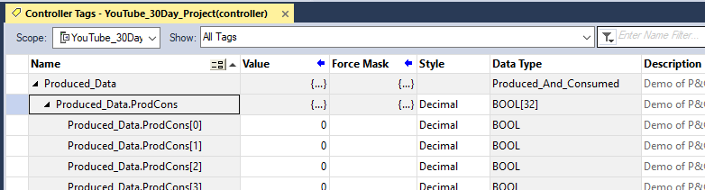
Top line has no index, only the data member has index due to it being an array.

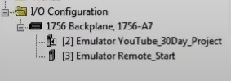
Now we do the similar operation for Consumed_Data then we create both of these in the other machine. Note that both processors are located in the I/O Configuration. Not clear how this plays out, where have we identified the other processor? What if we had 3 other processors, what is directing traffic?

It looks like we do not specify a controller until we are setting up the consumed tag(s). Then you have to click on the Connection button when in the properties of the consumed data tag. So it is necessary to set up that controller in your I/O Configuration tree.

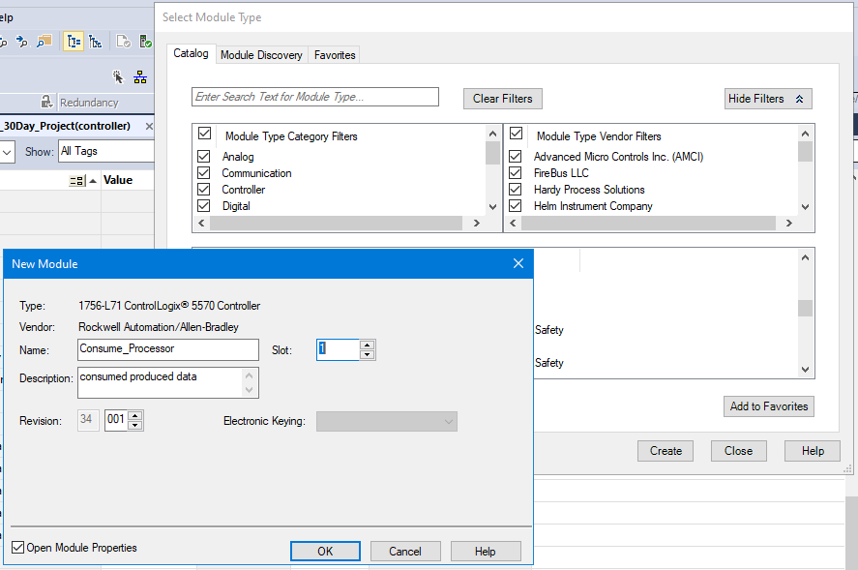

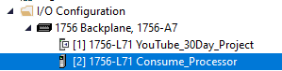

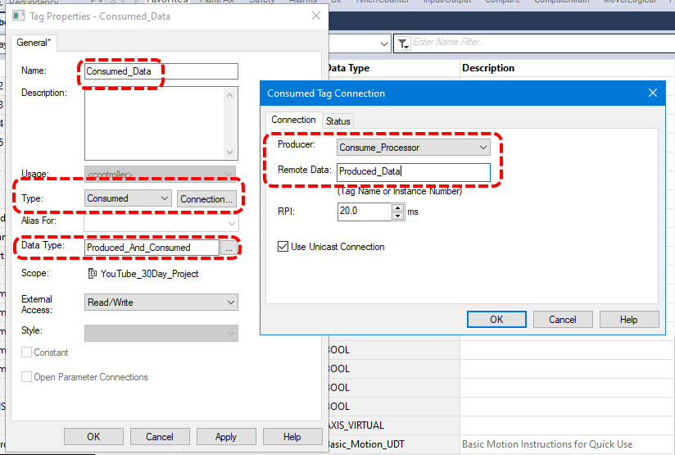
Consumed_Processor gets Produced_Data (from other processor).

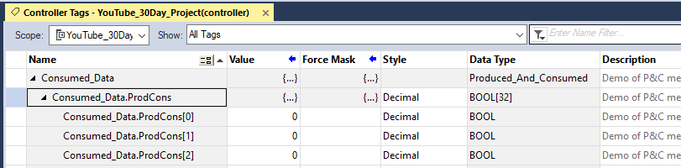
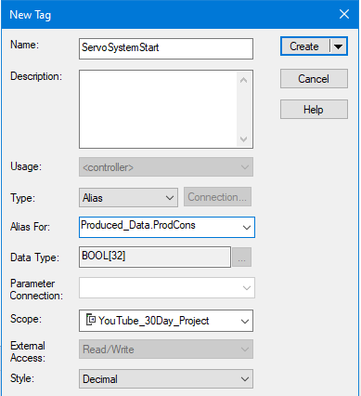
Now create a rung in PLC that will activate the remote tag (kind of assuming both machines require remote start of each other for demonstration purposes). Set up this button in MachineControl_47ms | MainProgram | MainRoutine.

Note that we select a specific instance of Produced_Data for this Bool.

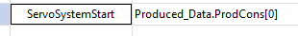

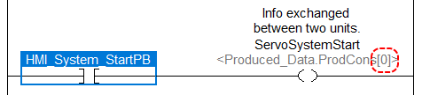

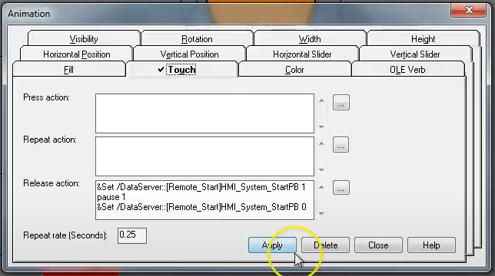

So now when we access data from the other processor via produce/consume we have to change the shortcut data path in the HMI as well.

The End

